sd | Year 3
Autumn | Week 1 | Week 2 | Week 3 | Week 4 | Week 5 | Week 6 | Week 7 | Week 8 and 9 |  | Week 9 | Week  10 | Week 11 | Week  12 | Week  13 | Week  14
Autumn | Stone Age Rocks! |  |  |  |  |  |  |  | Dig deep!
Autumn | 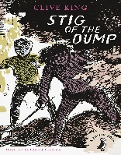  Stig of the dump- Clive King |  | The Street beneath my feet - Guillian &Zommer  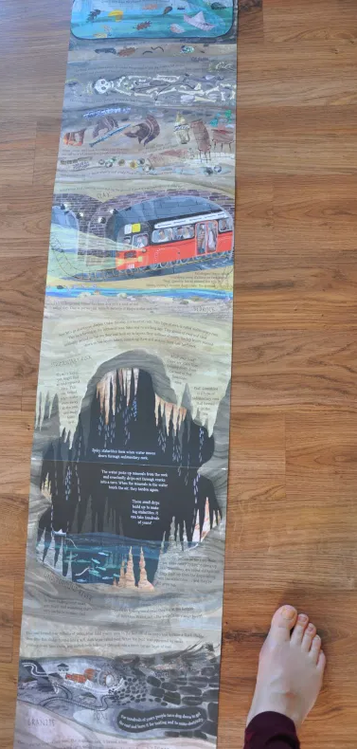  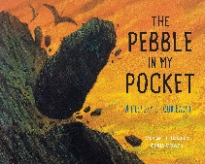  The Pebble in My Pocket: A History of Our Earth – Hooper & Coady | Stone girl, bone girl – Anholt  Fossil Girl – Brighton  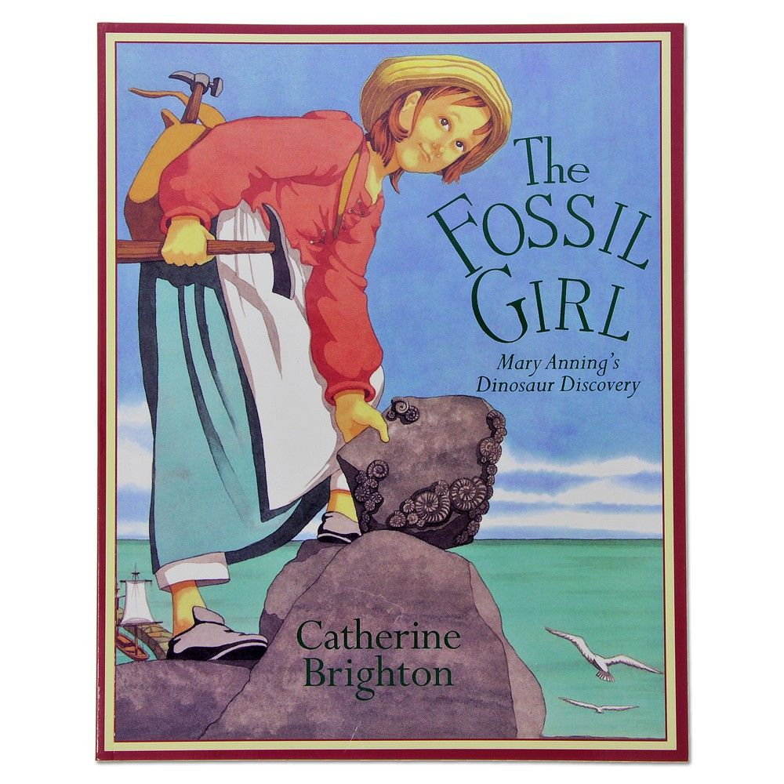  Fantastically great Women who changed the world – Pankhurst  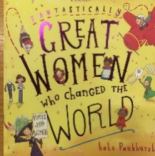 |  | Minnow and the bear – Blathwayt  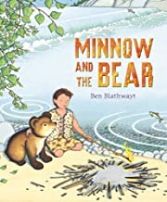  Wild Girl – Wormell  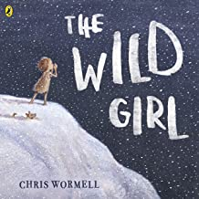 |  | Life in the Stone-Age -DK  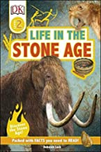  Find out Stone-Age – DK  Found Bronze Age Found Iron Age  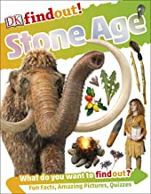 |  | 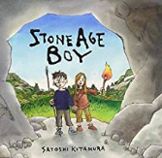  Stone Age Boy – Kitamura |  | The Quarry- anonymous  I was born in the Stone Age- Michael Rosen |  | How to wash a  Woolly Mammoth – Robinson & Hindley  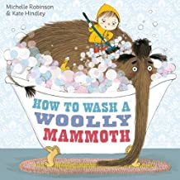
Shared Reading | Author focus - Satoshi Kitamura – The Smile Shop  Stig of the Dump (class novel)
WO | Recount from character’s perspective |  | Writing in role as a pebble about their formation or create what is under their feet | Mary Anning’s journal page  Or a time-line of her life based on the page from fantastically……  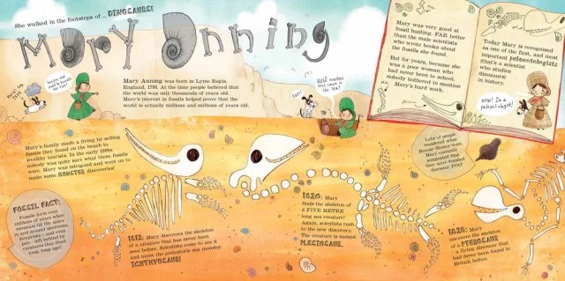 |  | Setting description  A character within that setting eg Minnow falling into the waterfall (adverbials) |  | Report using the double page from the text (linked to history)  (The two texts above have similar information but are pitched at different reading levels) |  | Narrative action writing  Dialogue  Link pages to history  Non chronological  Persuasive letter |  | Poetry- Write a free verse poem |  | Instruction text about washing a woolly mammoth

sd | Year 3
Spring | Week 1 | Week 2 | Week 3 | Week 4 | Week 5 | Week 6 | Week 7 | Week 8 | Week 9 |  |  | Week  10 | Week 11 | Week  12 | Week  13 | Week  14
Spring | On our doorstep
Spring | The greatest stories ever told- Tony Bradman—  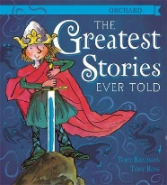  Sword in the stone and George and the dragon  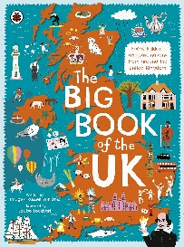  The big book of UK- Imogen Russell Williams pg32 |  | https://www.bbc.co.uk/newsround/21231575  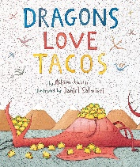  Dragons love tacos- Adam Rubin |  | Journey- Aaron Becker  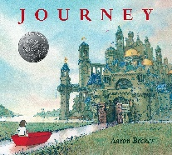  Where’s Wally?- Martin Handford    Home sweet home- Moira Butterfield  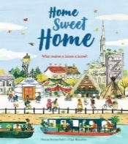 |  | A first book of nature- Nicola Davies  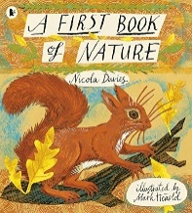  Water |  |  |  | It starts with a seed- Laura Knowles  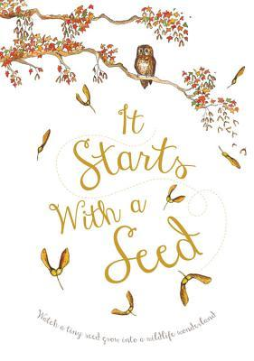  The extraordinary gardener- Sam Boughton  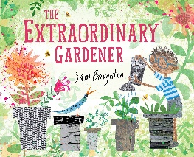 |  | 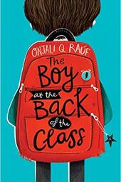  Boy at the back of the classroom- Onjali Rauf  All are welcome- Alexandra Penfold  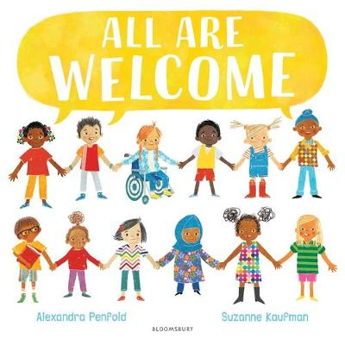
Shared Reading
WO | Rewriting a myth and legend- ENG |  | Persuasive letter persuading the dragon to eat a healthy diet- linked to science research- ENG  Persuasive letter against plans for H2 trains due to the impact on greenbelt land- WC |  | Non-chronological report based on Rochdale or Leeds based on research- WC  Setting description of our home town- Rochdale- ENG |  | Write a poem in similar style about water/ rivers |  |  | Explanation as to how plants are created- ENG |  |  | Recount from characters view point  To inform- all about refugees

sd | Year 3
Summer | Week 1 | Week 2 | Week 3 | Week 4 | Week 5 | Week 6 | Week 7 | Week 8 | Week 9 | Week  10 |  | Week 11 |  | Week  12 |  | Week  13 | Week  14
Summer | The Victorians- Full steam ahead!
Summer | 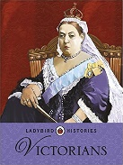  Victorians- Ladybird histories  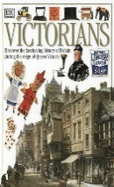  Victorians- discover the fascinating history of Britain during the reign of Queen Victoria. | https://www.ducksters.com/biography/women_leaders/queen_elizabeth_2.php  Biography of Queen Elizabeth II  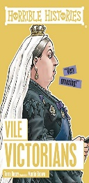  Horrible histories- Vile Victorians- by Terry Derry | I was there- Royal Nursemaid- by Jill Aktins  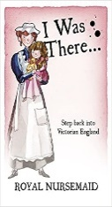  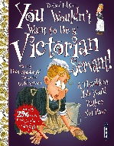  You wouldn’t want to be a Victorian servant!- by Fiona MacDonald.  Industrial revolution- by Peter Hepplewhite  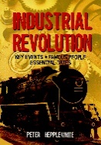 |  | Victorian girl’s diary- diary extract taken from My Story: Workhouse by Pamela Oldfield  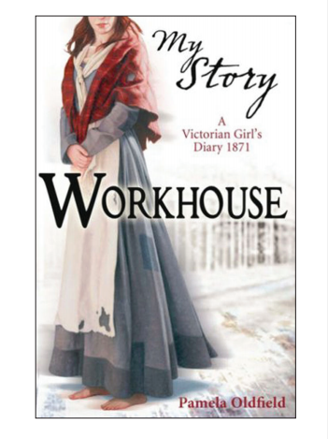  Children in Victorian times- Jill Barber  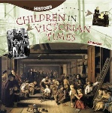  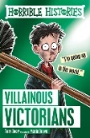  Horrible histories- Villainous Victorians- By Terry Derry  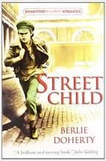  Chapter 14 from Street Child- by Berlie Doherty |  | 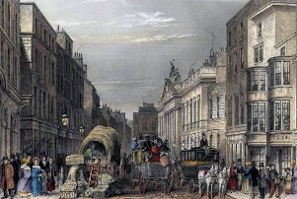  Picture stimulus  Preludes- T.S Eliot |  | Rosie Reverse engineer- Andrea Beaty  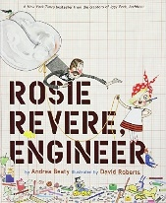  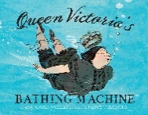  Queen Victoria’s bathing machine- by Gloria Whelan |  | 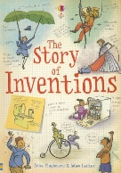  The story of invention- Anna Claybourne and Adam Larkum  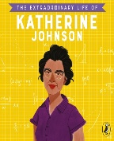  The extraordinary life of Katherine Johnson- Devika Jina |  |  |  | 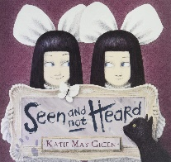  Seen not heard- Katie May Green  Video- Introduction of Toy story when the toys come alive  Picture stimulus of a Victorian home.
Shared Reading | I was there- Royal Nursemaid by Jill Aktins  Queen Victoria’s bathing machine by Gloria Whelan
WO | Write an biography of Queen Victoria |  | Persuasive advert to be a servant/nursemaid.  Cross curricular- persuasive letter to persuade their boss to pay them more. |  | Recount of a child working in a workhouse.  Cross curricular- Explanation of the jobs children used to do and the introduction of the new laws. |  | Write a sensory imagery poem using the picture stimulus |  | Write a newspaper report about Rosie’s great invention  Cross curricular- newspaper report about one of the inventions. |  |  |  | Write a narrative of the girls coming alive.  Setting description of a Victorian home.

