Summer 2026
Transition Booklet


Over the summer holidays, sometimes we can become worried and anxious about going back to school. Sometimes our tummies can feel funny and we can forget what school is like. This booklet is here to help you over the summer remember how great our school is and remind you of some of the changes as you move into your new class.

Schools have a year that starts in September and goes through to the next July. It is now July and soon school finishes for the summer holidays. All the children and teachers will have a long holiday. This is good. Things I might do when I’m not at school are...
Go to the park
Read a book
Go to a museum
Build a den
Paint rocks

My new teacher
On 3rd September 2026 my school starts a new year. I will move to a new classroom and have a new teacher. This is so that we can learn new things each school year. Next year I will learn in Year 4.

Key information
My next class will be Year 4
My teacher will be Miss McGarry-Clayton
The teaching Assistant will be Miss Slack
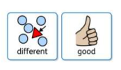
My school year will be Year 4

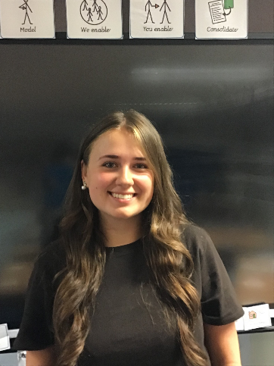
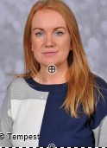

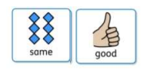
Miss MvGarry-Clayton
Miss Slack

My Classroom and My Space
Where I can put my things:
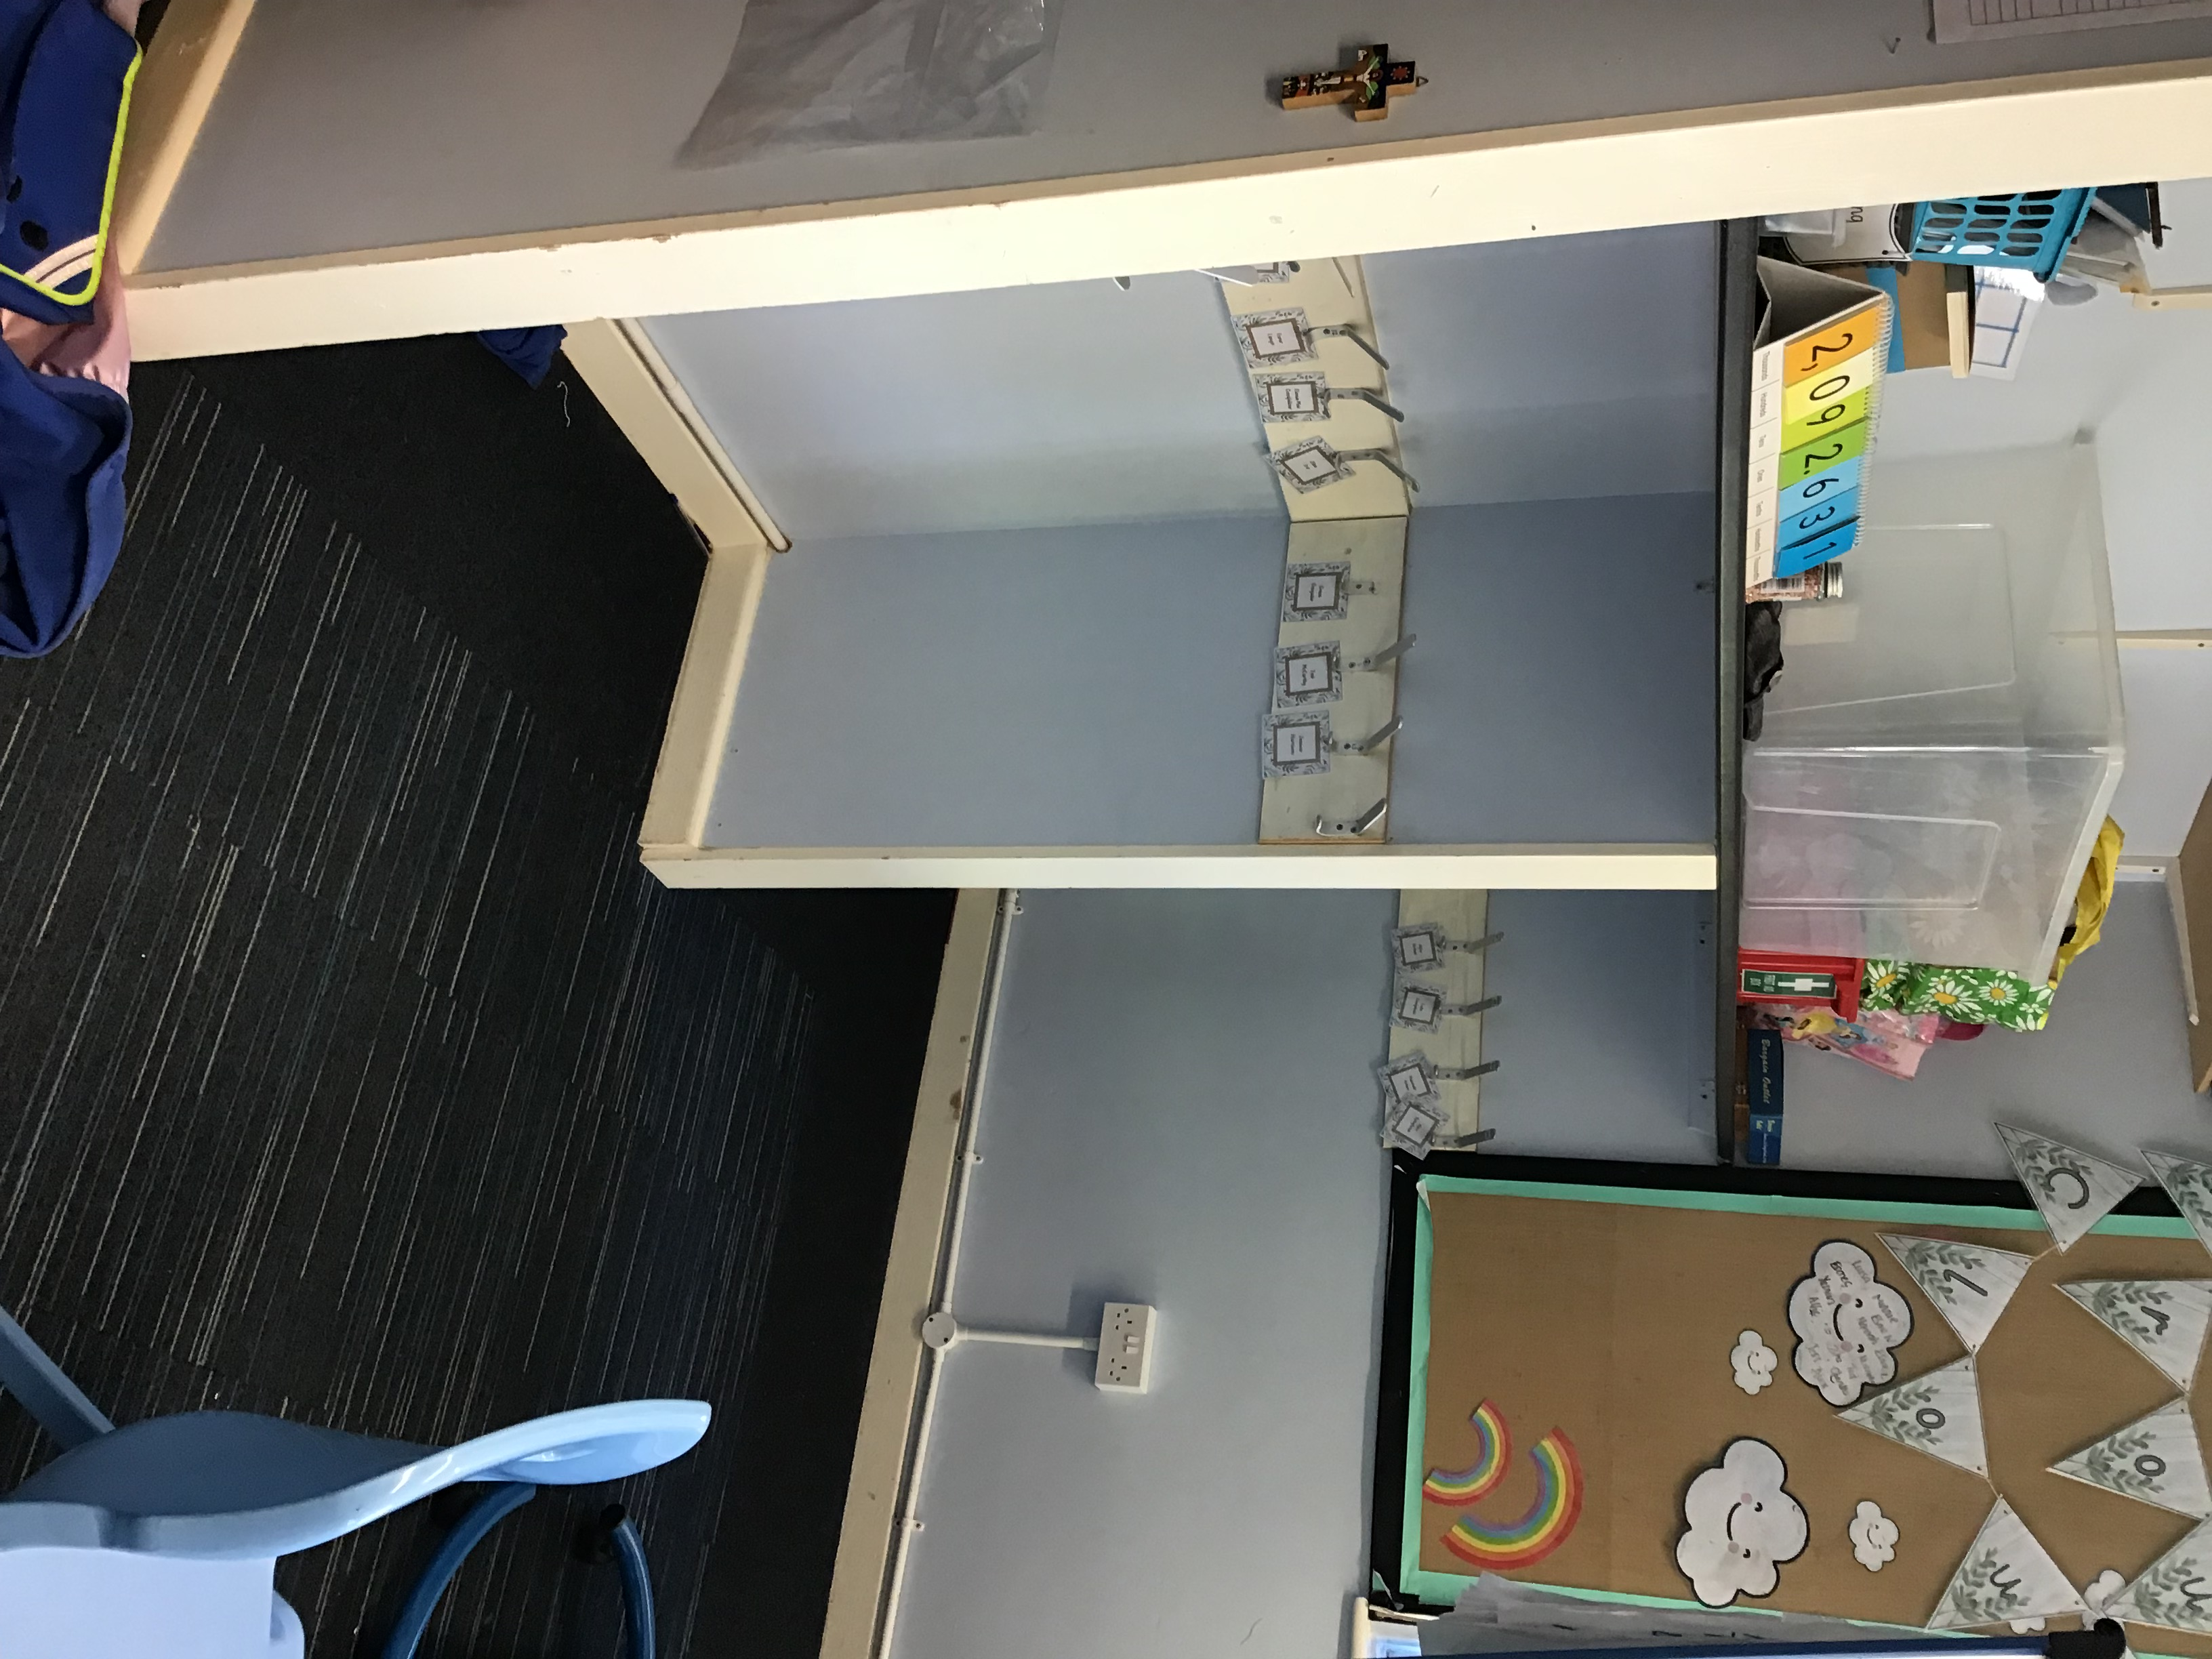
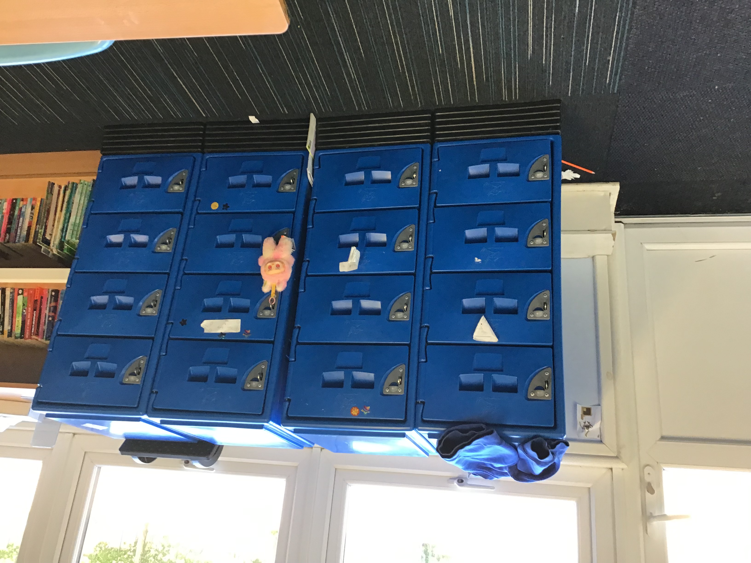

Where I can sit in my new class: 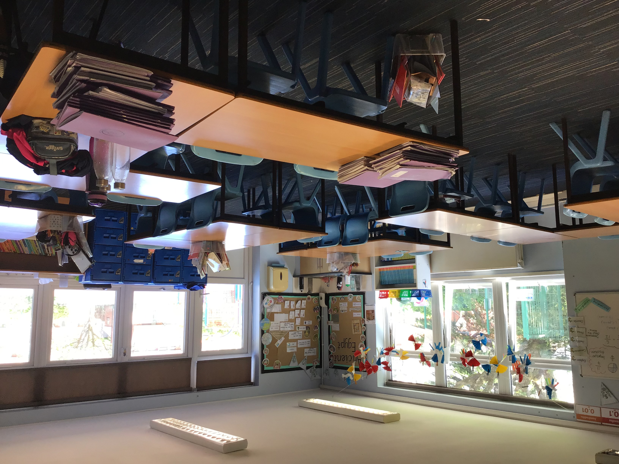

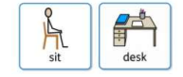

What we will do on the first day:
• Talk about school values
• Get to know each other
• Play games
• Learn about your teacher and friends
Playground
You will now play on this playground at break time and dinnertime with lots of children from other year groups.

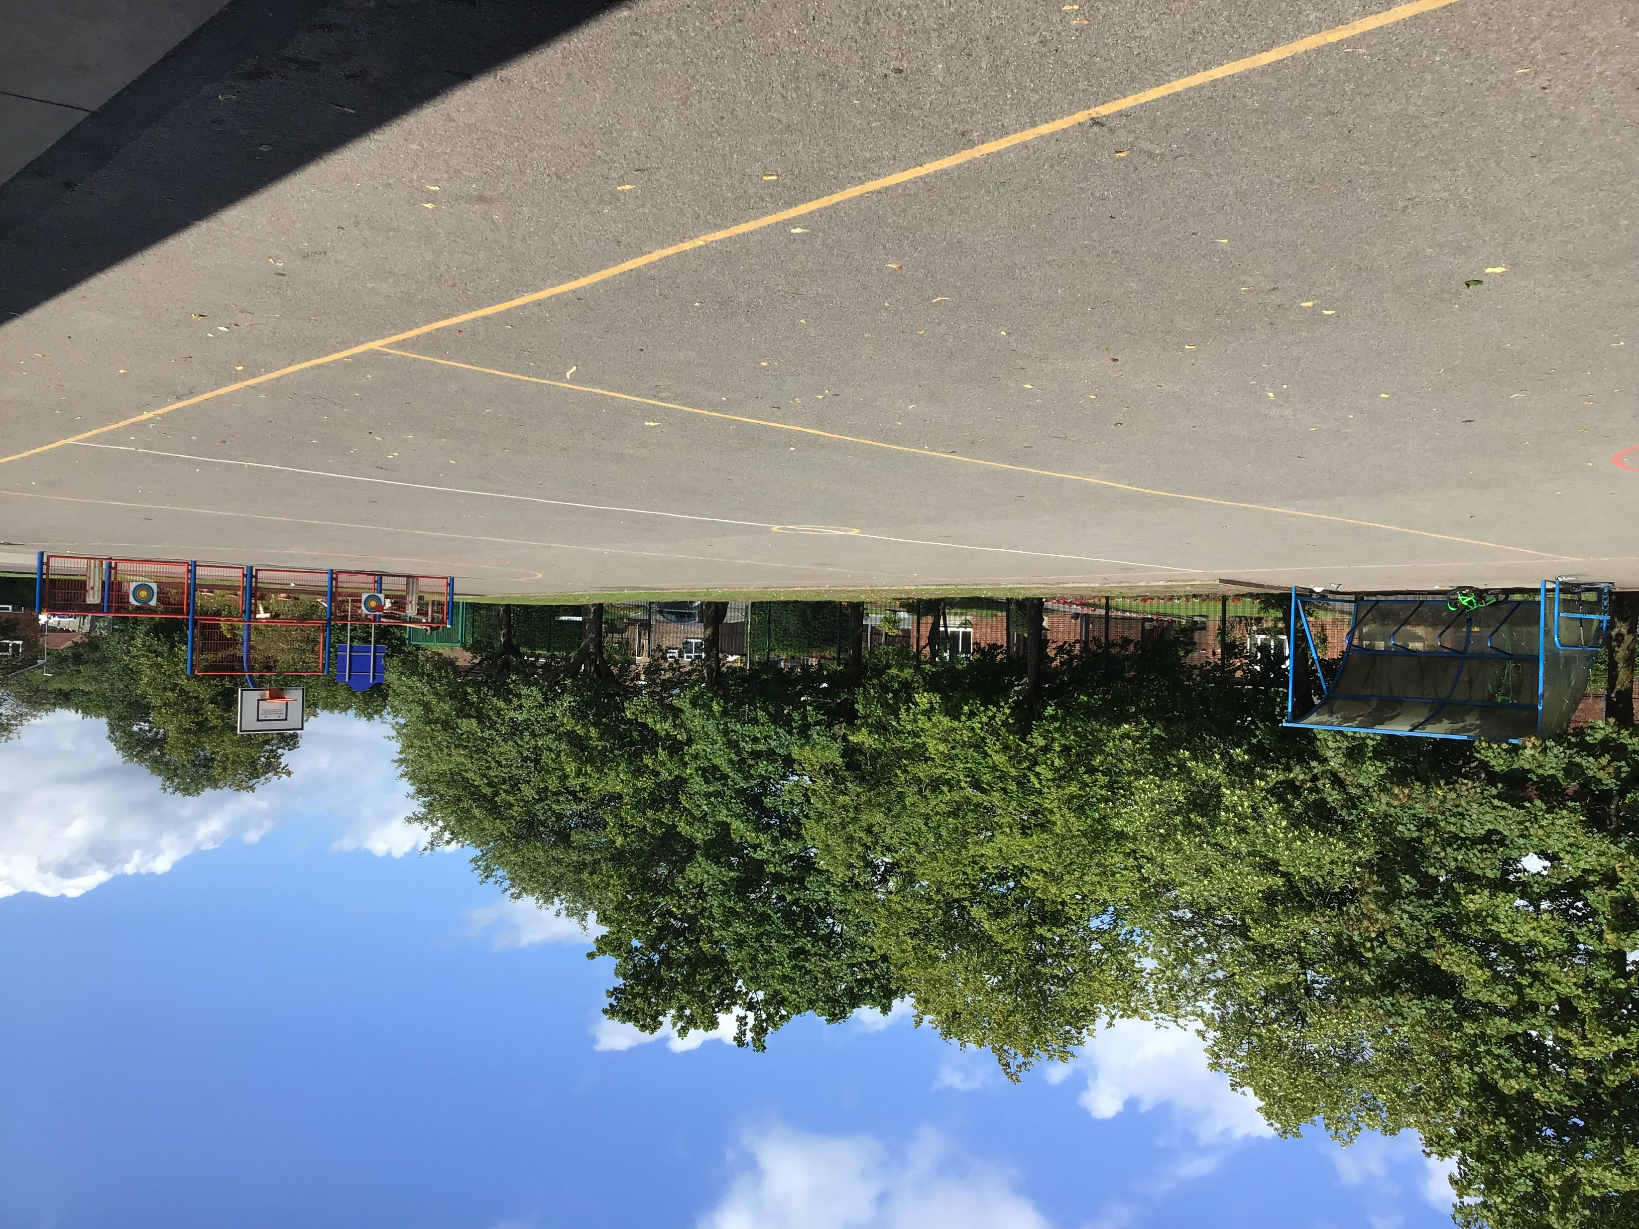

Classroom
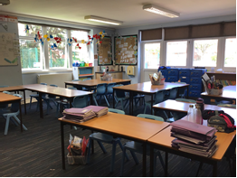

Your new classroom
It will have:
• a reading corner
• a sink
• tables and chairs
• windows
• my tray for you to put your things
• a whiteboard
• a visual timetable
• laptops/iPads
• a teaching assistant
• pegs for your coats and reading bag
• friends

Classroom door
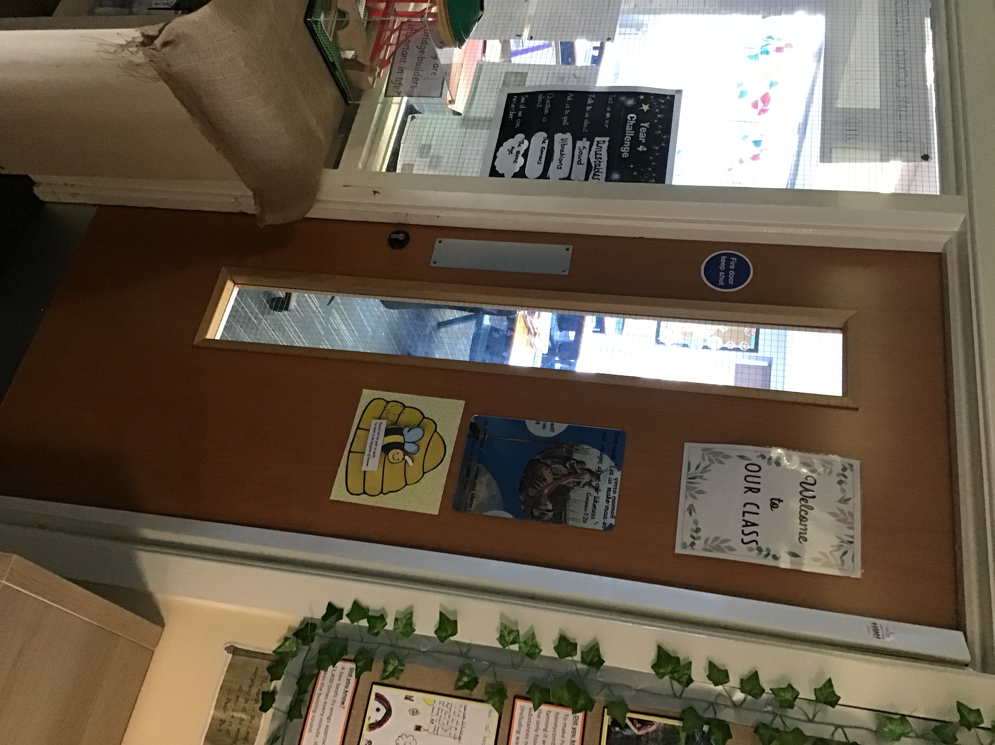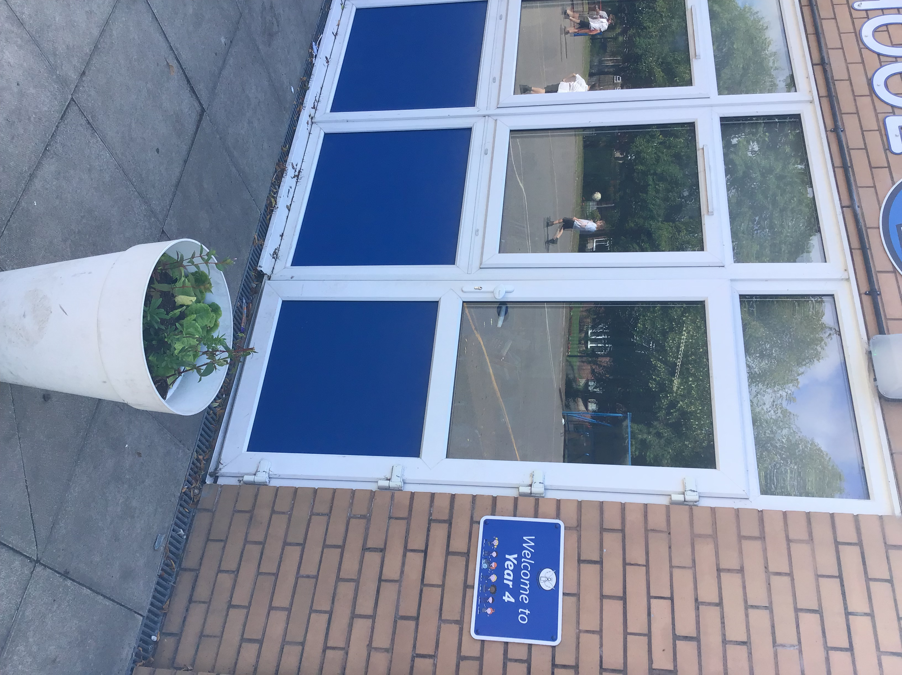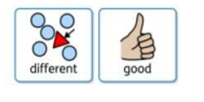

You will use this door to come in the mornings and go home from at hometime

It is likely that you can soon settle in and enjoy the new things that you do at school.

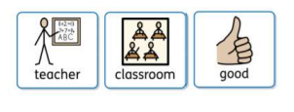
Soon it can seem like an ‘old’ classroom not a new one! You are on the way to being ready for the next school year!

Well done you!

Enjoy your summer holidays! See you in September!

