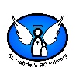
Hadrian’s Wall

Hadrian’s Wall was built by Romans and named after the roman emperor. It was 117.5 KM long and 6 meters high and 3 meters wide. It is in the North of England. It was built to keep out the pics and it was guarded for over 25 years.

D
Why did the Romans invade Britain and who invaded?

The Romans wanted to invade Britain for their resources such as:
Lead, Wood, Tin, Wool, Slaves, Gold, Silver, Corn and leather.

The Romans attempted to invade Britain 3 different times:
Julius Caesar – 55 BC Failed
Julius Caesar – 54 BC Failed
Claudius – AD 43 succeeded

To army left in 410 AD to defend other parts of their empire.

Julius Caesar
Popular Roman ruler. Invaded Britain twice but failed.
Claudius
Invaded Britain 97 years later and succeed.

.

The Romans
Artefacts in Ancient Rome
Clothes: Tools:
Toys:
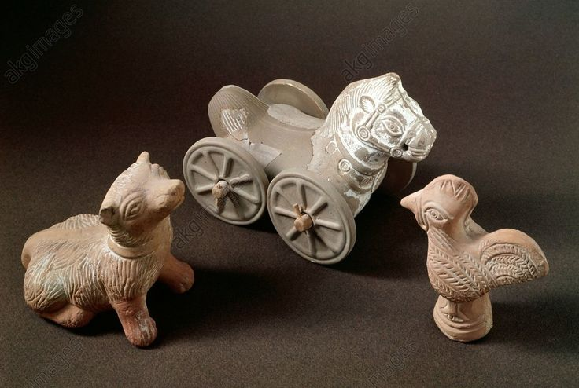
Key Vocabulary
AD | Anno Domini” in the year of our Lord”. AD is used to show dates after the birth of Jesus. This year is 2023AD
Armour | Special metal clothing that soldiers wore for protection in battle.
Auxiliary solider | A ‘helper’ recruited from a non-Roman tribe.
BC | Before Christ. A way of dating years before the birth of Jesus. The bigger the number BC, the longer ago in history it was.
Barbarian | A person from a different land believed to be inferior.
Celts | A person who lived in ancient Britain in the time before the Romans.
Citizen | A person with all the rights and protections of a nation or land.
Conquest | Taking control of a place by force, often with an army.
Empire | A group of countries ruled by a single person, government or country.
Emperor | The ruler of the empire.
Evidence | A sign to show something existed or is true.
Invasion | To enter a place in a forceful way.
Legion | A large group of soldiers who form a part of an army.
Legionary | A soldier in a Roman legion.
Revolt | To rise up and fight against a government.
Rebellion | An uprising or revolt by people who want to challenge what they believe is unfair treatment by rulers.
Roman Empire | The name used for the land that was controlled by the Romans.
Source | Gives us clues about the past.
Taxes | The way the government collects money
Tribe | A group of people who share the same culture and values.

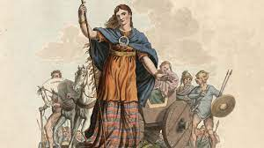
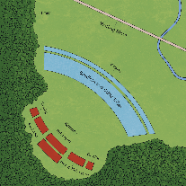
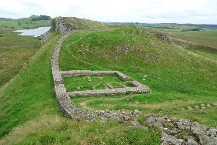
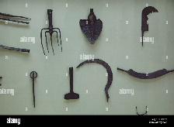
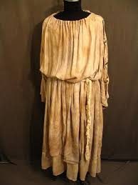
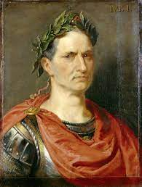
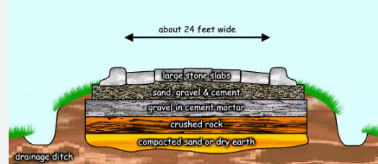
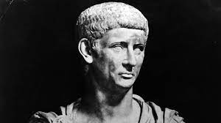
Queen Boudicca’s Rebellion

- Leader of the Iceni tribe.
- Romans stole for land and attacked her family.
- She persuaded Celts to join her.
- Defeated Romans in Colchester.
- Eventually her forces were defeated.
- Proved tribes could stand up the Romans.

During the last battle the Romans had less of an army but they had batter tactics to defeat the tribes.
Roman roads were built in straight lines so that enemies couldn’t hide behind bends. They were made with 5 different layers of rocks. Roman roads are still around today.
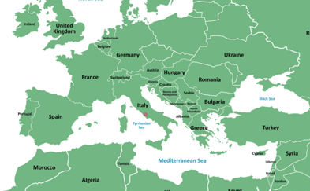
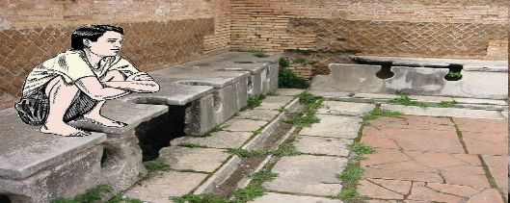
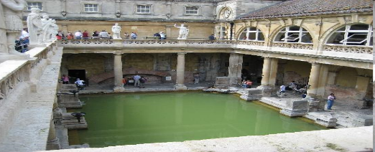
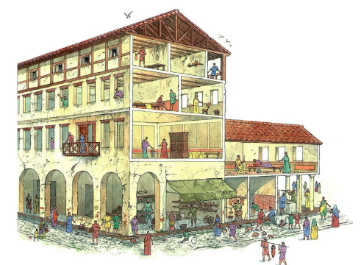
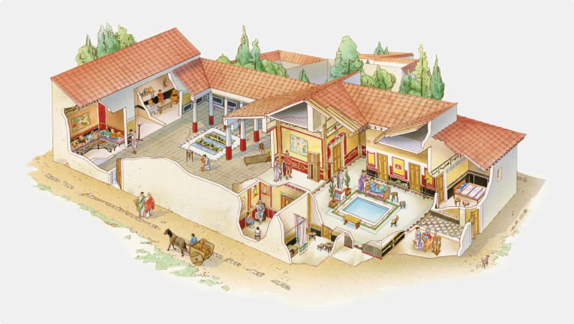
Rich homes: One family would in just this one house.(domus). They had underground heating. Often in the country side. Large courtyard.
Poor homes: Insulae, One family lived in one room. Shops on the bottom floor.
Rich food: Dormouse, Flamingo, Bread, Cheese, Wine
Poor food: Porridge, Vegetables, Beans and lentils
Sanitation: All bathed together and went to the same toilet and use a sponge on a stick to clean themselves.

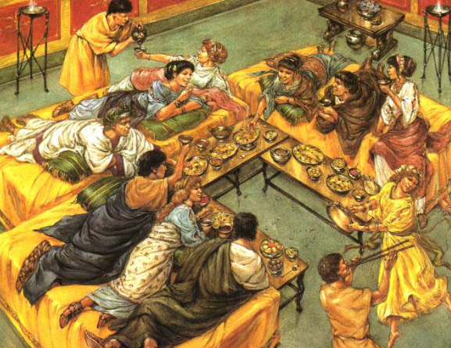
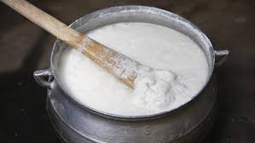
The Roman Empire grew and expanded over 850 years.

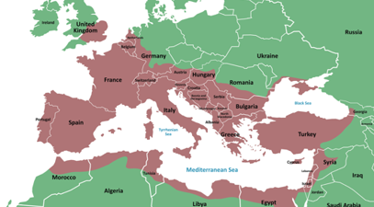
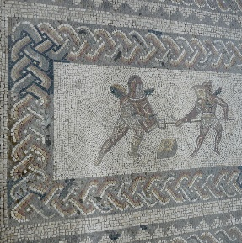
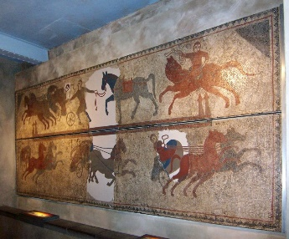
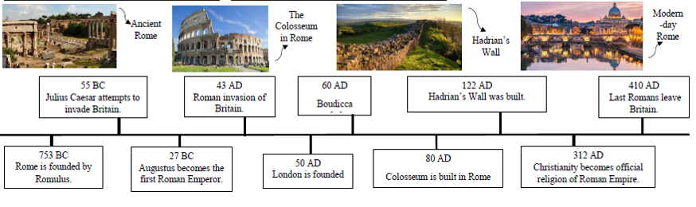
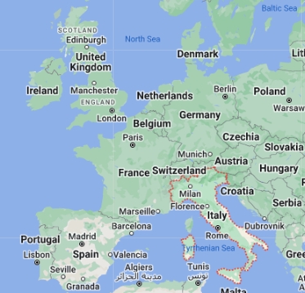
The Romans liked different types of Entertainment such as chariot racing and gladiator fighting.
Rome is in Italy. Italy is in Europe and so is the UK.

