Diagrams

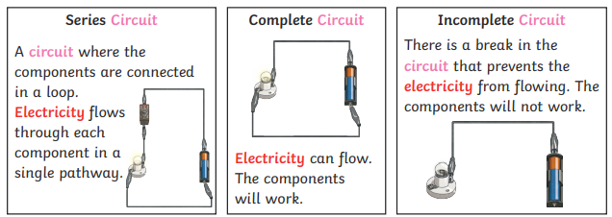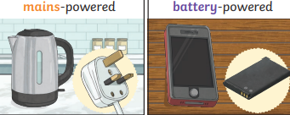
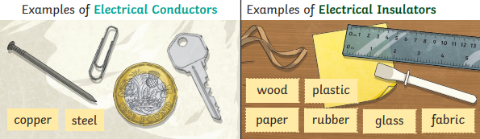
Key Vocabulary
Electricity | A type of energy which can be used in circuits to power up items.
Electrical appliance/device | Uses electricity to perform a function (e.g. cooker, TV, hairdryer).
Mains | The electricity that comes into your house through the wall sockets comes from the mains (electricity supply from power stations to houses).
Plug | A plastic object on electrical equipment with metal pins which fit into the holes of an electric socket and connects the equipment to electrical supply.
Electrical circuit | A complete route that an electrical current can flow around.
Complete circuit | A circuit which an electrical current can flow through.
Component | A device which transfers electrical energy into another form (e.g. a motor, or a lamp).
Cell | Used to generate electricity. One end of the cell is positive, ‘+’. The other is negative, ‘-’. A cell pushes the electric current from the positive end to the negative.
Battery | Can be one cell or many cells. It stores electrical energy until it is needed.
Connect/connections | A device used to join electrical conductors and create an electrical circuit.
Loose connection | When the electrical connection is not correct and can cause it to heat up.
Conductor | A material that lets electricity flow thought it.
Insulator | A material that stops electricity flowing through it.

What should I already know?
What a battery is
That electricity is dangerous

Subject: Science
Unit: Electricity
How and why do we hear sound?
Year group: Year 4
Term: Autumn 2

What will I know by the end of this unit?
- Know about common appliances that run on electricity
- Know how to construct a simple series electrical circuit.
- Identify and name the basic parts of the circuit, including cells, wires, bulbs, switches and buzzers.
- Know that a switch opens and closes a circuit.
- Know that a circuit needs to be closed for it to work.
- Know about some common conductors and insulators.
- Know that metals are good conductors.
- Know different types of energy that are used in the world including fossil fuel, renewable and non-renewable energy.
- Know how to stay safe around electrical products.

