Diagrams
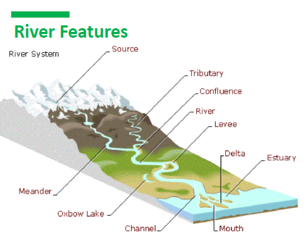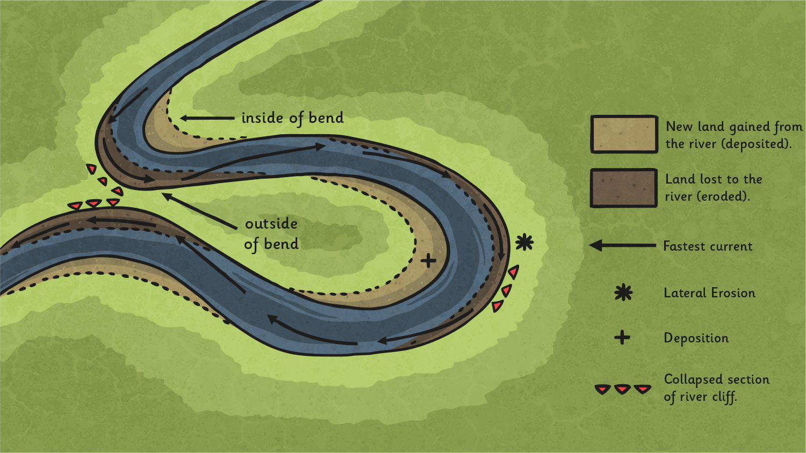

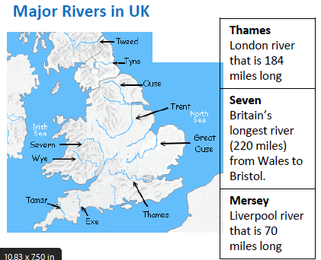

D
Key Vocabulary
Estuary | An estuary is an area where a  freshwater river or stream meets the  ocean.
Mouth | A river mouth is the part of a  river where the river flows into  another river, a lake, a reservoir, a  sea, or an ocean.
Source | The source of a river is where  it begins, usually in high ground.
Meander | A meander is a winding  curve or bend in a river.
Waterfall | Waterfalls form where  water rushes down steep hillsides in  upland areas and erodes the rocks.
Erosion | erosion occurs when the  fastest currents in the river carve  intensely into the banks.
Deposition | rocks and sediments  eroded from one part of the river is  deposited in another part
Tributary | When one stream meets  another and merge together, the  smaller stream is known as a  tributary.
Ox bow lake | Ox bow lakes are  created when the meander is so deep  that it cuts off a piece of the meander.
Delta | Deltas are often found at the  mouth of large rivers.
stream | A stream is a small body of  flowing water.

Rivers
Sticky knowledge:
- A meander is a winding curve or bend in a river.
- Ox bow lakes are created when the meander is so deep that it cuts off a piece of the meander.
- The River Nile is the world’s longest river and runs into the Mediterranean.
- The Amazon River is situated in Brazil and runs through the Amazon Rainforest.
- Erosion is the wearing away of the land by forces such as water, wind, and ice.
- Erosion has helped to form many interesting features of the
- Earth's surface including mountain peaks, valleys, and coastlines.
- Deposition is when the materials from erosion are dropped in a new location.
- The source of a river is where it begins, usually in high ground.



