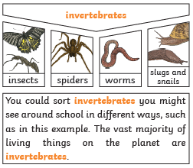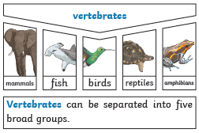
What should I already know?

Year group: Year 4
Term: Summer 1

Subject: Science
Unit: Living things and their habitats
How and why do we hear sound?
Diagrams
You can use classification keys to help group, identify and name a variety of living things. Here is an example of a classification key:
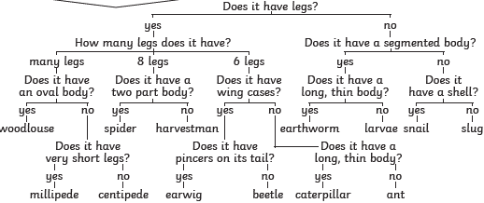
Key Vocabulary
organisms | This is another word that can be used to mean ‘living things’.
life processes | The things living things do to stay alive.
respiration | A process where plants and animals use oxygen gas from the air to help turn their food into energy.
sensitivity | The way living things react to changes in their environment.
reproduction | The process through which young are produced.
excretion | The process by which living things get rid of waste products.
nutrition | The process of obtaining food to provide living things with energy to live and stay healthy.
habitat | The specific area or place in which particular animals or plants may live.
environment | An environment contains many habitats and these include areas where there are both living and non-living things.
endangered species | A plant or animal where there are not many of their species left and scientists are concerned that the species may become extinct.
extinct | When a species has no more members alive on the planet, it is extinct.
classification | This is where plants or animals are placed into groups according to their similarities.
vertebrates | Animals with a backbone.
invertebrates | Animals without a backbone.
specimen | A particular plant or animal that scientists study to find out about its species.
characteristics | The distinguishing features or qualities that

Life processes:
To stay alive and healthy, all living things need certain condition that let them carry out the sever life processes:
Movement
Respiration
Sensitivity
Growth
Reproduction
Excretion
Nutrition

What will I know by the end of this unit?

Environment
Changes to an environment can be natural or caused by humans. Changes to an environment can have positive as well as negative effects. Here are some examples of things that can change an environment.
Natural
• earthquakes • storms • floods • droughts • wildfires • the seasons
Human made
• deforestation • pollution • urbanisation • the introduction of new animal or plant species to an environment • creating new nature reserves
Plants and animals rely on the environment to give them everything they need. Therefore, when habitats change, it can be very dangerous to the plants and animals that live there.

