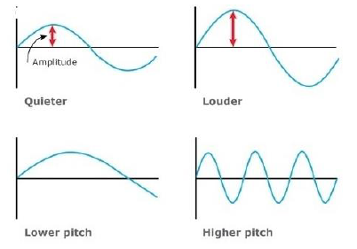
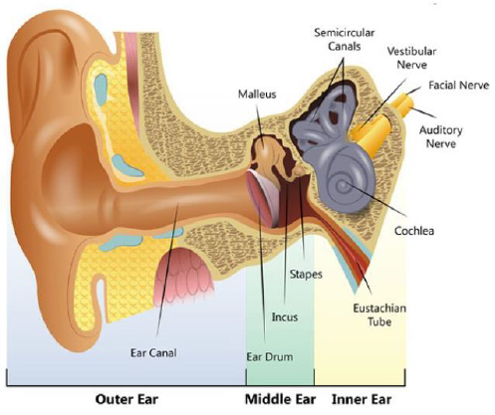
Diagrams

Key Vocabulary
sound | Vibrations that travel through the air or another medium and can be heard when they reach an ear. The object vibrating is called the source.
vibrations | Move back and forth rapidly.
amplitude | The strength of a sound wave.
frequency | The speed of a vibration, which determines the pitch.
volume | How loud or quiet a sound is. The bigger the vibration, the louder the volume.
molecule | A miniscule portion of matter. Everything is made of molecules (even the air)
Sound waves | A pattern of movement through different states of matter.(Solid, liquids and gases)
Sound-proofing | To use materials to stop sound from travelling and being heard.
Transmit | To pass something on
Source | Where something starts.
Pitch | How high or low the sound is

What should I already know?
Hearing is one of my five senses.
Sounds can be combined using musical instruments.
What the word vibration means.
Subject: Science
Unit: How and why do we hear sound?
How and why do we hear sound?
Year group: Year 4
Term: Autumn 1

What will I know by the end of this unit?
- When objects vibrate (even if we cannot see this), a sound is made.
- The vibration makes the air molecules around the object vibrate and the air vibrations enter the ear. These are called sound waves.
- Sound waves need to travel through a medium (such as air, gases, water, glass, stone and brick) by vibrating the molecules.
- Sound enters the ear canal—the sound makes the ear drum vibrate—this vibration moves the chain of tiny bones in the middle ear. The last bone hits the membrane window in the cochlea (inner ear) and makes the cochlea fluid move. The moving fluid triggers the hearing nerves, which send signals to the brain.
- Sound cannot travel through a vacuum due to there being no molecules to carry the vibrations.
- Light travels faster than sound-this is why we see lightning before we hear its thunder!
- Sound gets louder as we get closer to the source. It gets quieter as we move away from it.

