What should I already know?
Different materials have different properties.

Key Vocabulary
States of matter | Materials can be one of three states: solid liquid or gases. Some materials can change from one state back to another and back again.
Solids | These are materials that keep their shape unless a force is applied to them. They can be hard, soft or even squashy. They take up the same amount of space no matter what has happened to them.
Liquids | Liquids take the shape of their container. They can change the amount of space they take up. They can flow or be poured.
Gases | Gases can spread out to completely fill the container or room they are in. They do not have any fixed shape but they do have a mass.
Water vapour | This is water that takes the form of gas. When water is boiled it evaporates into water vapour.
Melt | When a solid changes to a liquid.
Freeze | When a liquid changes to a solid
Evaporate | Liquid turns into a gas
Condense | Gas turns into a liquid
Precipitation | Liquid or solid partials that fall from a cloud as rain, sleet, hail or snow.

Diagrams
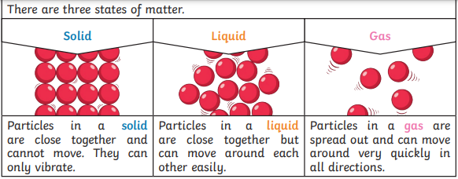
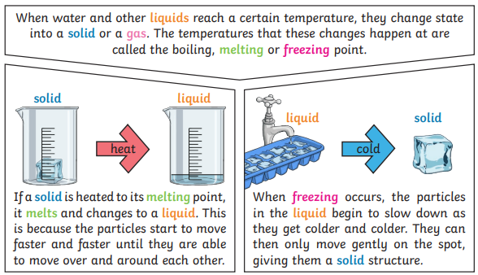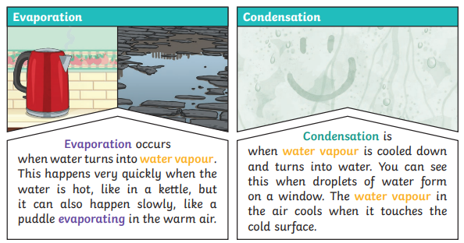

Subject: Science
Unit: States of matter
How and why do we hear sound?
Year group: Year 4
Term: Spring 2

What will I know by the end of this unit?
- The different between solid, liquids and gases.
- Solid, Liquid and gases properties.
- Reversible and irreversible change.
- Melting and freezing
- Evaporation and condensation.
- The water cycle

The water cycle


