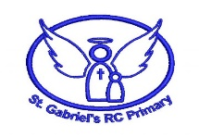
Year 3 Animals Including Humans Knowledge Organiser.
Key Vocabulary
extinction | no longer existing at all
vitamin | nutrients that humans need in order to grow, reproduce and be healthy
Balanced diet | consisting of the adequate amounts of all the necessary nutrients recommended for a healthy growth
cartilage | tough flexible tissue in the body that is usually replaced by bone
invertebrate | an animal without a backbone
contract | to make smaller by drawing together
loosen | to make or become less tight or rigidly fixed
ribcage | the bony enclosing wall of the chest consisting of the ribs and their connecting parts
insect | a group of small and often winged animals that are arthropods having six jointed legs and a body formed of a head, thorax and abdomen
exoskelton | means ‘outside skelton’ a hard covering that supports and protects the bodies of some types of animals

In this topic I will learn…
To identify that animals, including humans, need the right types and amount of nutrition | Proteins are good for growth, carbohydrates for energy and fruit and vegetables provide vitamins and minerals which help keep us healthy e.g. calcium for healthy bones and teeth)  Getting the right amount of each food group is called a balanced diet.  Lack of nutrition can cause ill health e.g. lack of vitamin D can lead to rickets.
To identify that humans and some other animals have skeletons and muscles for support, protection and movement | Some animals such a insects have an exoskeltona solid covering on the outside of their body.  Invertebrates (such as earthworms and slugs) have water held inside by muscles which act like a skeleton.  Skeletons provide support for muscles and protect the body, for example the ribcage protects the vital organs in the human body  Human skeletons are made up of bones and cartilage.

Find out more
Significant Scientist
Marie Curie
(1867-1934)
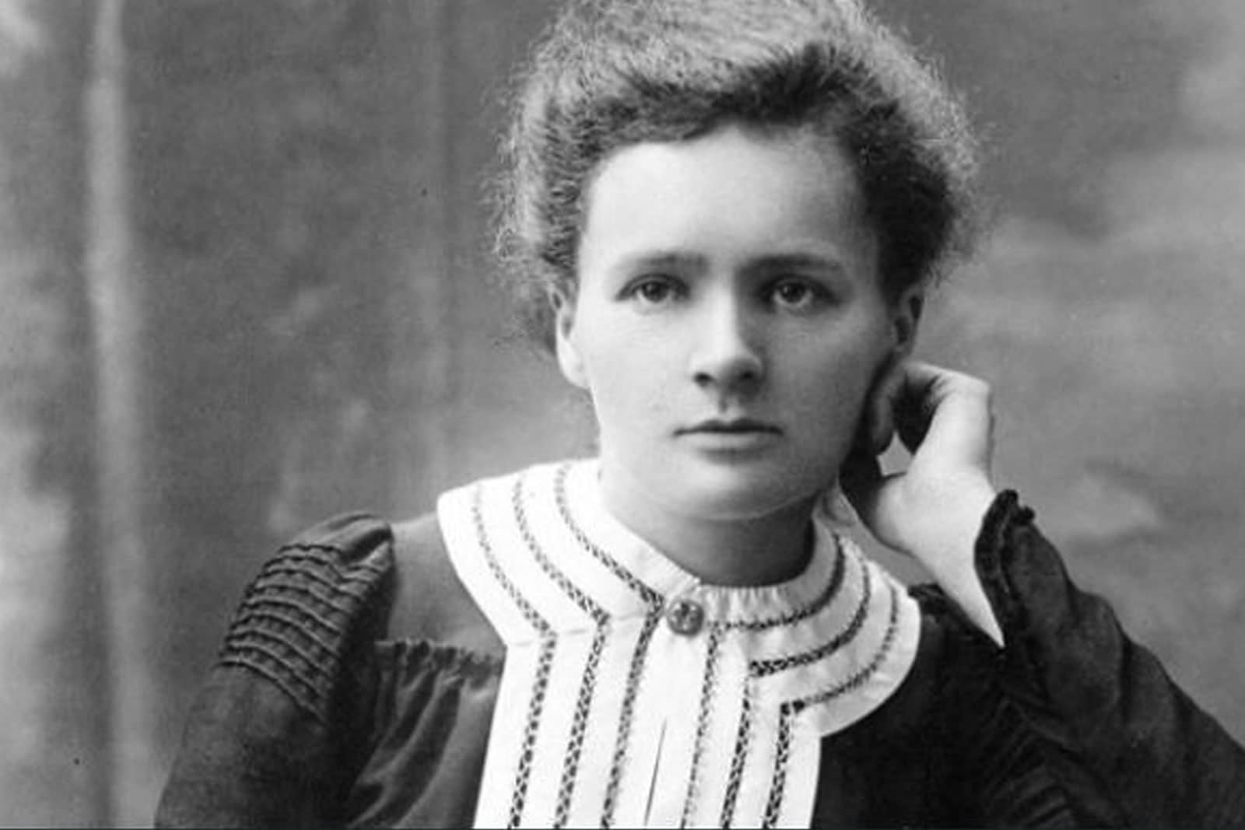
She is best known for developing the use of X-Rays and radiation in medicine examination.



