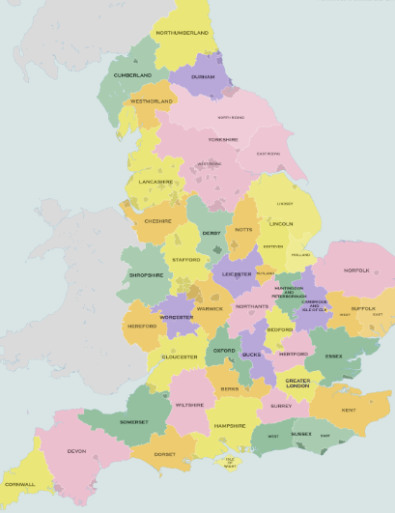
The equator, northern hemisphere, southern hemisphere and Arctic and Antarctic circles
Counties around the UK
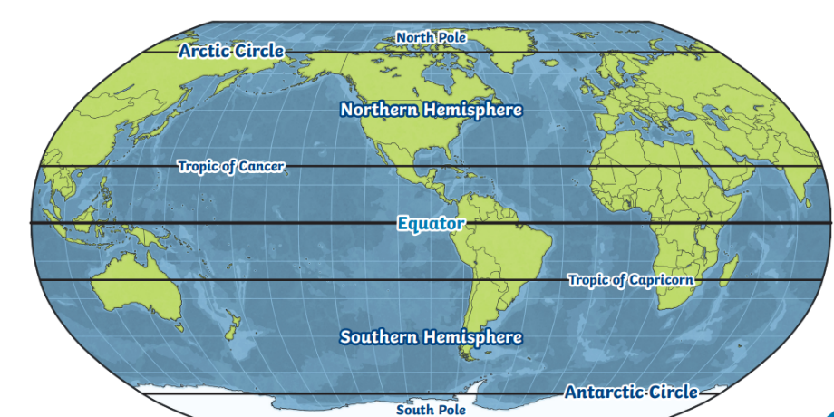

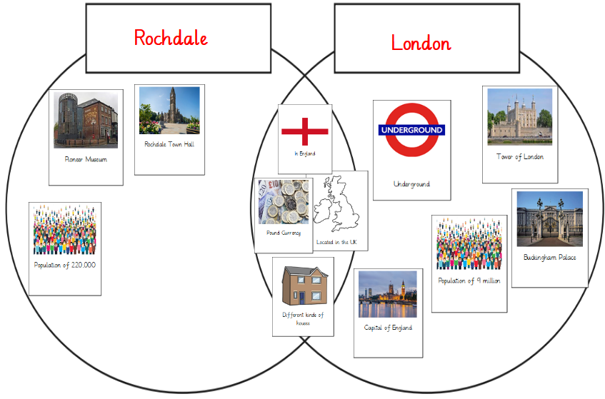

Rochdale on a map of Europe.
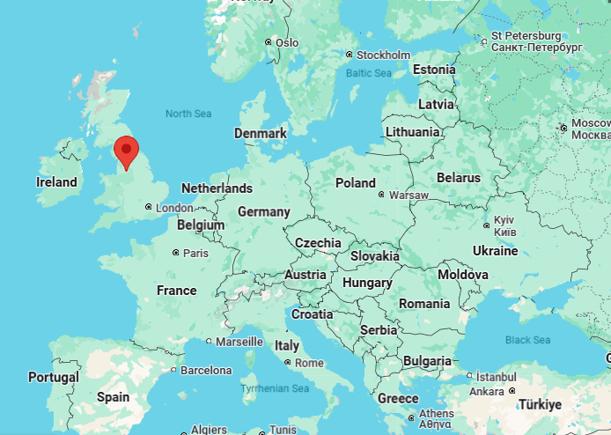
Compare Rochdale and London
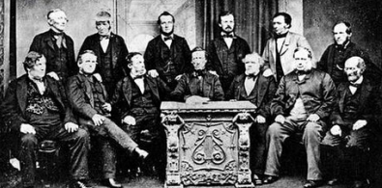
Key vocabulary
City: A large town that usually has a cathedral.
Country: A large area of land where people live under the same Government.
British Isles: Great Britain, Ireland and all nearby islands.
United Kingdom: England, Scotland, Wales and Northern Ireland.
Coast: The land next to the ocean.
Capital city: The main city in a country, usually where the Government is located.
Region: A large area of land that is different from other areas of land
Continent: very large landmasses found on Earth.
Mill: A building where raw materials like cotton are made into basic products such as cloth
Industrial revolution: The industrial revolution was a time of change. Products that were often made by hand began to be made by machines in factories and mills
Pioneers: Individuals who started or came up with a revolutionary idea.
Cooperative: Everyone working together to achieve a common goal.
Major cities in the UK
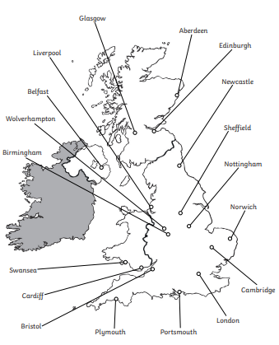
Why Rochdale is called 'the birthplace of Co-operation'?
In Victorian times, a group of people came together to set up an organisation called a co-operative. The word means working together in a group to achieve something good for everyone who is a member.
Why was the first 'Co-op' a success?
The rules of the society were what helped it to grow. The more people who joined, the bigger the co-op got and the more power they had to give members what they needed.

Regions of England


