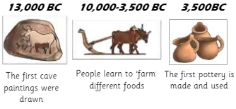
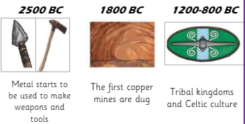
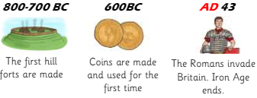
Palaeolithic Period | Mesolithic Period | Neolithic Period
700,000 BC -10,000 BC | 10,000 BC – 4,500 BC | 4,500 BC– 2,400 BC
There was an ice age during the Stone age and one third of the earth was covered in ice. Archaeologist have discovered that Early humans (Neanderthals and early Homo sapiens) lived at the same time, but Neanderthals became extinct 30,000 years ago.  Early humans arrived in Britain 800,000 years ago. They lived in caves and were nomadic hunter gatherers who moved around seasonally to find food, some hunted animals while others would forage for nuts, berries and shellfish.  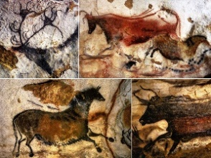  They created cave paintings – the Lascaux Caves are famous for hunting scenes and the Cave of Hands for handprints. They developed tools from stone, bone and wood, such as spears and axes, to help with hunting and daily life  The Bronze Age: During this era, people discovered how to make bronze. This was a huge development and meant their tools would be much stronger.  The Iron Age: This was the last period of prehistoric Britain before the Romans arrived. People were making even more useful tools and learned to make them out of Iron. People who lived at this time are now often called ‘Celts’. Celts were farmers and lived as part of a tribe.  Stone Age – Mesolithic and Neolithic Life | During the Mesolithic era, Stone Age people were still nomadic but are thought to have lived in tents made with wood or animal bones and animal skins with a layer of moss, reeds and other soft plant materials for the floor.  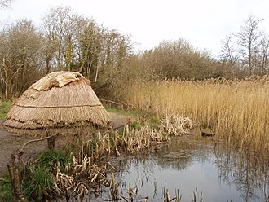  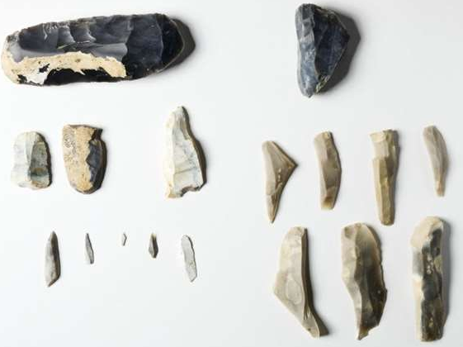  Stone tools are still used but are polished, sharpened and adapted for use as spears and arrowheads. | Farming and the creation of organised settlements was the biggest change in human history. Stone Age people began to settle in villages.  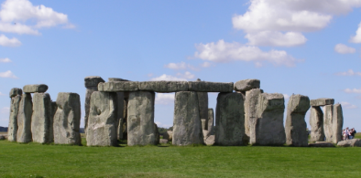  There is evidence of settlements, such as the one at Skara Brae, often made up of simple roundhouses built from stone. They were built into mounds of rubbish known as midden (small stones, shells, mud and animal bones), which would provide stability and insulation. These houses had beds, storage shelves and a fireplace in the middle.  Religion and Trade continued to develop and large round megaliths, like Stonehenge, were built!
 | Bronze Age | 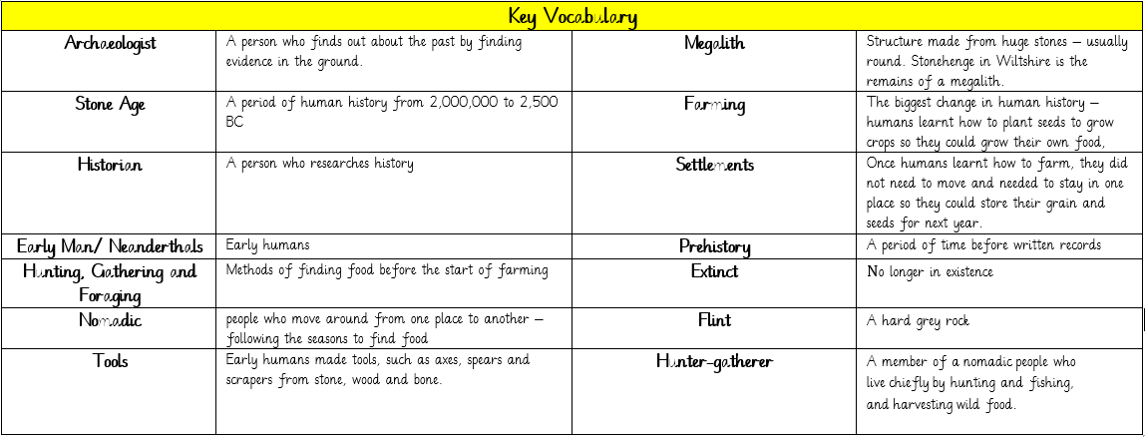  Iron Age

