Key Dates
1838 | Queen Victoria crowned aged 18.
1840 | Queen Victoria married Prince Albert.
1842 | Children under 10 can no longer work in underground mines.
1844 | Children aged 8-13 can no longer work for more than 6.5 hours per day.
1856 | Each county has to have its own police force.
1861 | Prince Albert died of typhoid.
1864 | Children under 10 can no longer work as chimney sweeps
1870 | Schools are built for children aged 5-10.
1872 | The first FA Cup Final takes place
1880 | The Education Act makes schooling compulsory for all children aged 5-10.
1901 | Queen Victoria dies and Edward VII becomes King.
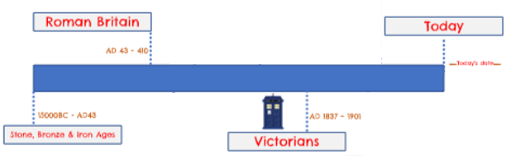
The Industrial Revolution -1750 and 1900
People began to realise that coal and steam could be used to power factories, large machines, flour and cotton mills. This reduced the time it took to make something and increased the amount that could be made and so the Industrial Revolution began. Huge factories were built and towns expanded.

Queen Victoria: The period of time between 1837 to 1901 was when Queen Victoria reigned over Britain. During her 63 year reign, there was a huge contrast between how the rich and poor Victorians lived. Queen Victoria led the expansion of the British empire and saw major changes to all aspects of Britain due to exciting discoveries and inventions.
Vocabulary
Era | an important period of history
Empire | a group of territories or peoples under one ruler
Monarch | a person who reigns over a kingdom or empire
Reign | the time during which a monarch rules
Pauper | a very poor person
Rural | areas which are not towns or cities.
Urban | places where buildings and places where people work and live are all close together
Industry | a group of companies that all produce the same thing.
Industrial Revolution | a time of major change in the way products were made.
Revolution | a big change in something
Migrate | move to a different area to find work or better living conditions.

Lord Shaftesbury
Encouraged the establishment of schools to give working children an education outside of workhouses.
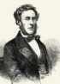
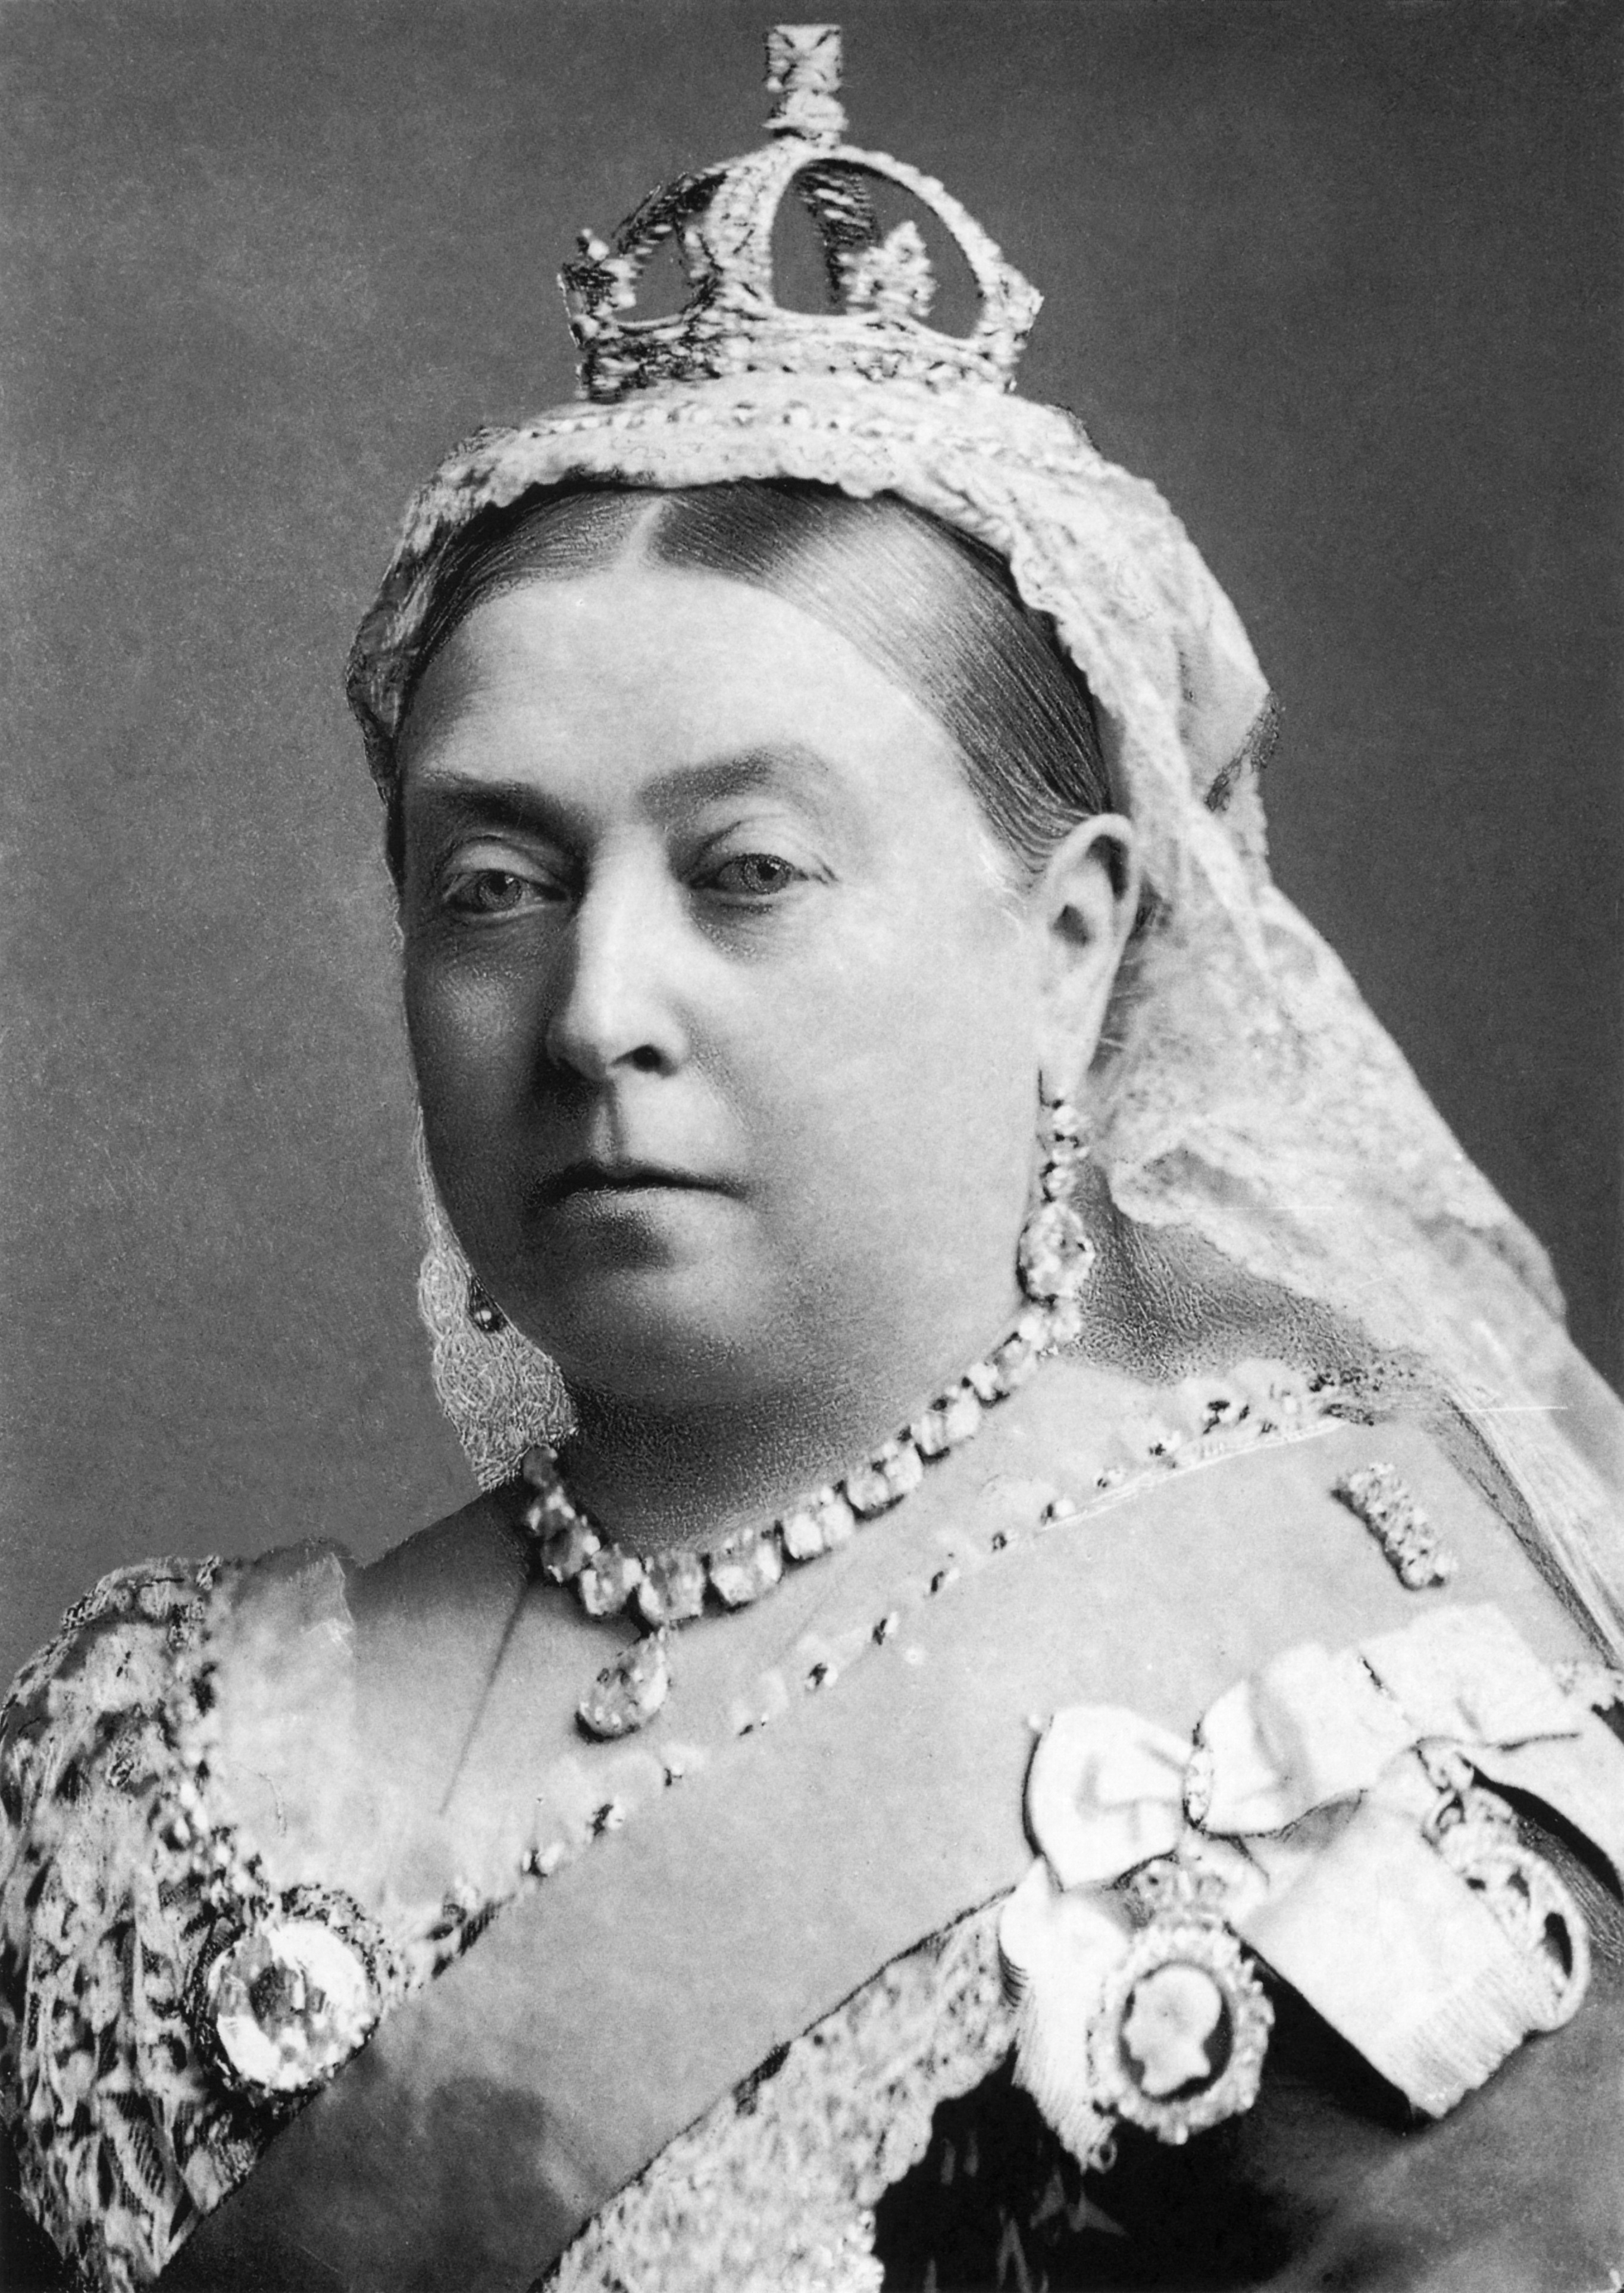

Key Inventions


