

Reception
Information for Parents

This booklet is intended to give families an overview of the Reception timetable, routines and other specific information to Reception. Your child will need to familiarise themselves with the new routines in September so please read this booklet together.
Teaching Staff
Welcome to Reception
The Reception teacher for this year is:
 Mrs R. Gray
The teaching assistant and apprentice who will be working with the children in class are:
Miss Manning and Miss Sheridan

Classroom doors open at 8:40am – 8:45am
Lunchtime starts at 11:45am
School finishes for collection 3.15pm
Being Healthy


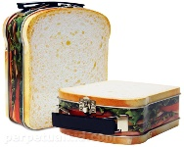
Only healthy snacks are allowed during snack times, these are provided through the free fruit scheme.
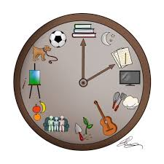

Please send your child with a water bottle filled with fresh water each day (no cordials).
Routines
.
Packed lunches are to be as healthy as possible and not include any fizzy drinks.

We ask that for birthday celebrations, your child shares a book with the class to be kept in the class library or brings in a small token item for their friends e.g a pencil. No treats are allowed due to school’s healthy status. We ask that you follow this rule. The children can wear non-uniform on their birthday. If their birthday falls over a weekend or during the summer holidays then children can wear heir own clothes on the last week of term.

PE lessons in Reception are on: Fridays (Subject to change - Physical activities are encouraged throughout the week both indoors and outdoors to work on fine and gross motor skills.)
P.E
Children will come into school dressed for P.E. on their particular day.
Your child will need:

- School logo PE kits – royal blue logo t-shirt blue / black shorts (Jogging bottoms for colder days).
- Trainers instead of pumps for outside (please ensure Velcro fastening if your child cannot tie their own laces)
- Please ensure your child’s name is on all PE kit items.
Please listen to your child read as much as you can, daily where possible. Please comment on your child’s reading and let us know how many pages they’ve read or if they have completed the book by signing in their reading diary.
Reading / Homework
English Homework |  | Maths Homework
Reading / Key words | 3 times a week | Numbots – counting and number bonds (once it has been launched) | 3 times a week
Each child is issued with a Times Tables Rockstar login which the children are encouraged to practise at home as well as complete in school(This is for learning multiplication facts-Not needed at the start of Reception.
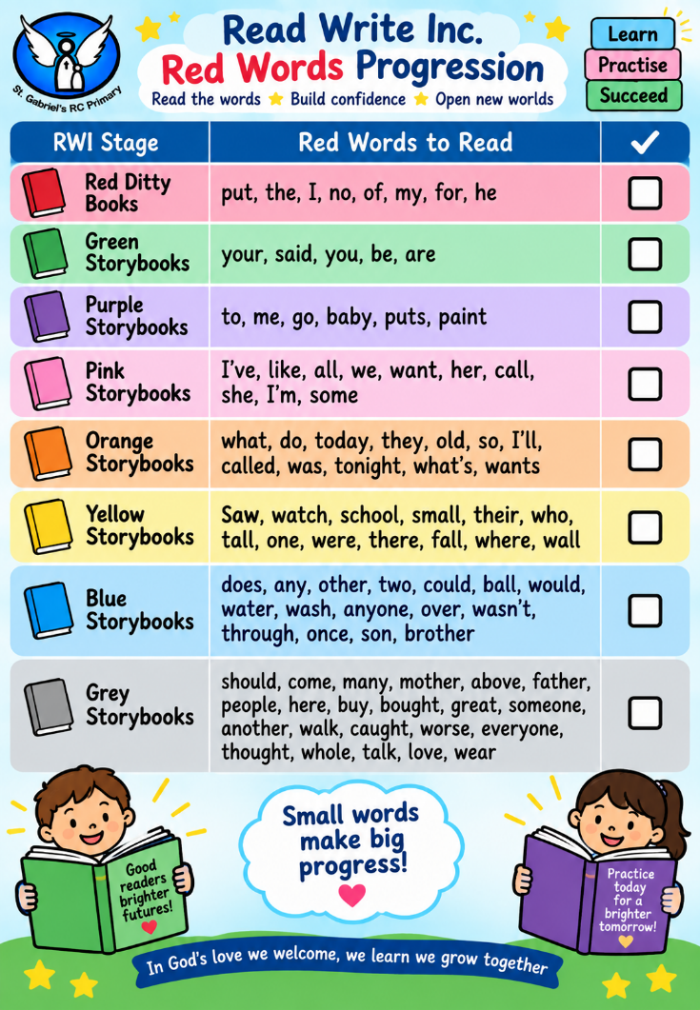
Two high frequency words will be sent home each half term for the children to learn to read by sight and spell.
As we learn each of the letter sounds in phonics, children will be taught how to form the letters accurately. Formal lessons for handwriting will begin in year 1 and children are taught to join. Please encourage best handwriting in all work.
Behaviour
Handwriting
We expect exceptional behaviour at all times and reinforce our rules and routines daily.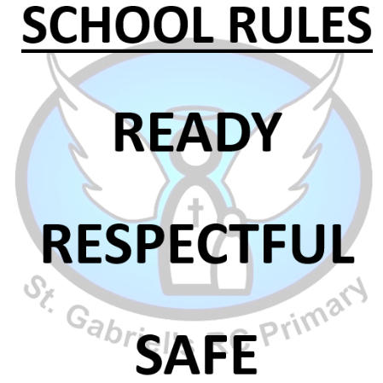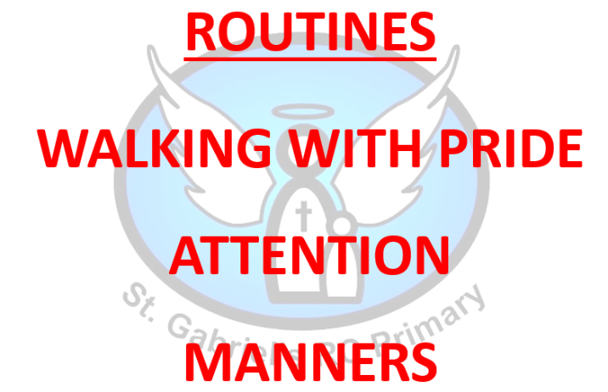
We encourage the children to learn from any poor behaviour choices they make.
For positive behaviour that goes above and beyond what is expected the children are rewarded with either: Hot Chocolate Friday, Postcards/notes home, Phone calls home.

Learning Behaviour
In school, we want the children to become responsible learners. In Early Years, these are called the Characteristics of Effective Learning. We do this by promoting the following:

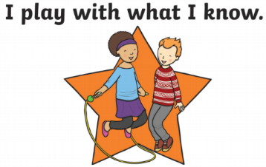
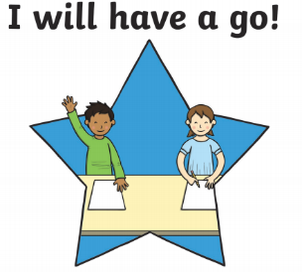
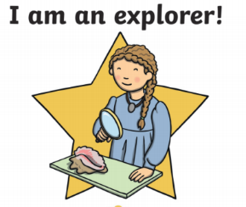
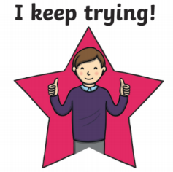

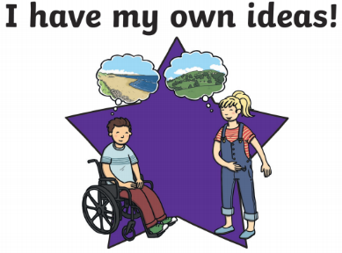
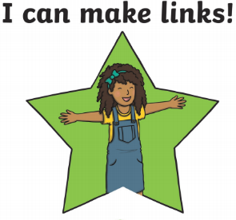
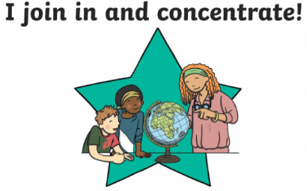


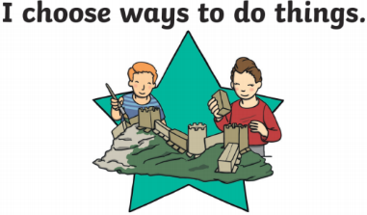

Class Prayers
Prayer of the Cross  From my head to my heart,  From my shoulder to my shoulder,  I love you God my Father.  Jesus, friend of little children,  Be a friend to me.  The Sign of the Cross  In the name of the Father  and of the Son  and of the Holy Spirit. Amen. | School Prayer  This is our school  Let Peace dwell here  Let the rooms be full of happiness  Let love abide here  Love of one another, Love of humankind,  Love of life itself and Love of God.  Let us remember that as many hands build a house,  So many hearts make our school.  Amen
Uniform

Uniform  Bag- Your child will receive a reading pack to carry their books. This is the only bag allowed in school. | - St. Gabriel’s School V collar sweatshirt or cardigan  - Grey trousers, grey skirt / pinafore dress  - White shirt  - Tie (Optional for reception)  - Black shoes, they can fasten (not trainers) –Wellington Boots essential in EYFS  - Grey socks / white socks or grey / black tights  - Waterproof coat  - Hat/Scarf (winter) or sunhat (summer)  - Blue/white gingham dress in summer
Uniform – Optional Items | - School logo coat  - All weather suit
PE Uniform Indoor | - School logo PE kits – royal blue logo t-shirt blue / black shorts  - Trainers
PE Uniform Outdoor | - Blue / Black jogging bottoms or leggings  - Blue / Black sweatshirt (no hoods)  - Trainers

- Please ensure all clothing items have your child’s name in.
- Only watches and stud earrings to be worn. Studs are to be covered during PE and watches to be removed.
- Long hair must be tied up. No extreme hairstyles or large bows are permitted.

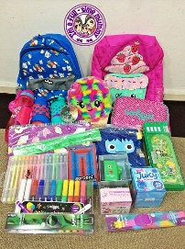
Children should not bring in their own pencil cases – all equipment is provided by school. This includes colouring materials, pens, pencils etc…
School Equipment
Children do not need a school bag. We provide and encourage children to use their reading pack/book bags only as there is limited space in the classrooms and cloakrooms.
Please encourage your child to be independent and prepared to hand in their reading books etc… themselves.
Drop Off and Collection
After School Clubs
It is important that children enter on their own as to ensure the cloakroom environment doesn’t become overwhelming, and to promote their independence. On collection (3:15pm) your child will be allowed to leave once a teacher has seen the collecting adult. Please notify the office in good time if someone else picks up.

There are a variety of after school clubs throughout the year across the school. If these arise for Reception then further information will be sent out in a letter.
Wrap Around Care / Before and After School Care
Breakfast Club now has 2 sessions a 7.45am start which costs £4 and an 8.00am start which costs £3, any child entering before 8am will be charged £4.

After School Club operates from 3.15pm – 5.45pm each weekday during term time only and is run by FUNDA. More information can be found by following the link.
https://www.fundaactive.com/wraparound-st-gabriels

If your child is going to be absent from school please leave a message on the school answering service on 01706 650280 leaving your child’s name, explain the reason for absence and when you expect your child to return to school.
Reporting Absence / Communication


Ways of communication with parents are via the Arbor app. Please ensure you download the app and set notifications to on. The school newsletter is sent out
every Friday via email from Arbor. The newsletter can also be found on the school
website along with any other information you may need.
The school X (formerly Twitter) account is: @stgabscastleton. Please follow us.
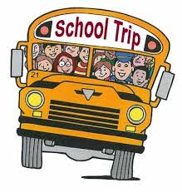
Class teachers also communicate the children’s learning via Seesaw. This is an app you can download to follow your child’s learning. Ask the teacher for a QR code to get started. We want to enhance the children’s learning through school trips and other experiences such as visitors coming into school. Throughout the year your child may be selected to go on a school trip. We ask for a set contribution towards this to enable it to take place as school cannot afford to continually subsidise these opportunities. Therefore, if not enough money is received, we may have to cancel the trips and monies will be lost. Trips will be running when it is safe to do so.
Holidays in Term Time
School Trips

We endeavour to stay open at all times because we want to make every day count. We can authorise absence for some, very rare circumstances but we cannot authorise absences for holidays. If you wish to go on holiday during term time this needs to be put in writing to the Headteacher. It is parents’ duty to have their child attending school and fines may be issued.

Throughout the year children work from the Early Years Curriculum. They are assessed at the end of the year if have achieved the Early Learning Goals in these areas. These are covered in the 7 Areas of Learning
Early Learning Goals

- Communication and Language
- Physical Development
- Personal, Social and Emotional Development
- Literacy
- Mathematics
- Understanding the World
- Expressive Arts & Design

Additional Needs

If you feel your child would benefit from provision over and above their current needs please speak with the class teacher.
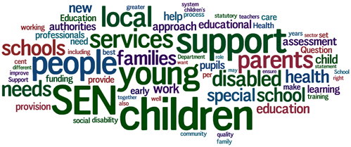
The school SENDco is available to answer any questions you may have regarding any additional needs. The school works hard on providing a personalised programme of education and Pupil Passports are devised and reviewed termly with the class teacher, SENDco, parents and children. For more information regarding this, please speak with the SENDco Miss L. Doyle (year 2 teacher).
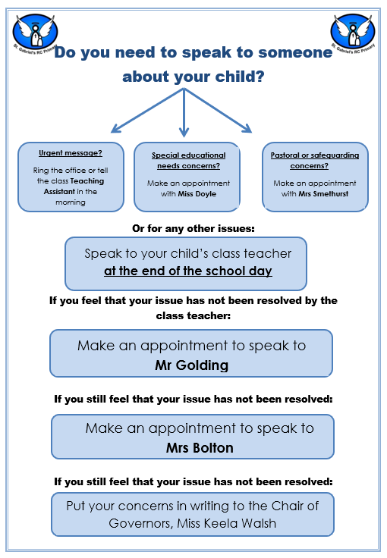
Speaking with Staff

This is a guide of what your child will be learning this year.
EYFS Curriculum
 |  | Autumn 1 | Autumn 2 | Spring 1 | Spring 2 | Summer 1 | Summer 2
TITLE |  | Marvellous Me | To infinity, and beyond! | Superheroes…to the rescue | All things bright and beautiful | Amazing Animals | We’re all going on a Summer Holiday.
Religion |  | Creation and Covenant | Prophecy and promise | Galilee to Jerusalem | Desert to garden | To the ends of the Earth | Dialogue and encounter
Shared reading/ phonics |  | Oral blending  Set 1 sounds | Oral blending  Set 1 sounds  Dittys | Set 2 Sounds | Red Level | Green/Purple Level
Text, word, sentence structure and punctuation. |  | Talk Through stories: Children are immersed in a story and learn key vocabulary and meanings. Look into characters, problems, emotions and using vocabulary in the right context.  Drawing Club: Children will be given a story, traditional tale or video clip as context to use their imagination. Children use drawing, mark making and build upon their phonics throughout the year to write for their own purpose.
Maths  Mastering number – building on number skills throughout the year. |  | Build on number from their home and nursery environments, and further develop their subitising and counting skills. Explore the composition of numbers within 5. They will begin to compare sets of objects and use the language of comparison. |  | Pupils will continue to develop their subitising and counting skills and explore the composition of numbers within and beyond 5. They will begin to identify when two sets are equal or unequal and connect two equal groups to doubles. They will begin to connect quantities to numerals. |  | Pupils will consolidate their counting skills, counting to larger numbers and developing a wider range of counting strategies. They will secure knowledge of number facts through varied practice.
Knowledge and Understanding of the world |  | Senses Individual changes  Significant people  Past and Present home and toys. | Seasons Light & Dark Christmas – Special events  Exploring space environment | Health & Nutrition Special events – Chinese New Year | Seasons Plants  Growth & Change  Farm animals  Cooking – Potato Latkes | Mini beasts, animals, dinosaurs | Weather  Float/Sink Weather  Places, environment and compare countries  Summer- Seaside
Expressive Arts  (Open ended crafts available throughout the year) |  | Autumn craft  Drawing skills  Loose parts – self portraits | Christmas craft  Space themed art | Winter craft  Paper puppets | Spring craft  Animal observational drawings. | Easter craft  Split pin animals | Watercolours – Seaside  Sea creatures  African art – Jewellery
Music |  | Nursery Rhymes  St. Gabriel’s Day song | Nativity Songs  Express and move to space music. |  | Jack & the Beanstalk songs |  | Seaside songs
Physical Development  PE |  | FUNDA Curriculum  Travelling forwards, backwards & crawling. | FUNDA Curriculum  Running, jumping and balancing. | FUNDA Curriculum  Finding space, hopping & skipping. | FUNDA Curriculum  Throwing underarm, overarm & catching | FUNDA Curriculum  Throwing to targets, rolling & dribbling | FUNDA Curriculum  Kicking, striking with 1/2 hands
 |  | Children work on their fine motor and gross motor skills throughout the year. Examples of how fine motor skills are developed include; ‘Funky Fingers’ station, dough disco, pencil work. Gross motor skills can be improved through exercises, ‘squiggle whilst you wiggle’ and there are many opportunities with large construction equipment, water play to develop further. Formal lessons will include spatial awareness, balance, managing risks etc.
PSHE |  | Health and Wellbeing and Relationships - are covered by the Ten : Ten ‘Life to the Full’ scheme of work.  Living in the Wider World is covered through:  Shared Responsibilities – Caritas in Action (Stewardship and Rights & Responsibilities), school rules and Eco Schools. Looking after chicks.  Communities – Knowledge and understanding of the world (People who help us).  Media Literacy and Digital Resilience – E-Awareness lessons and E-safety week.  Economic Wellbeing: Aspirations, Work and Career – Career day assemblies / guest speakers from the community and from charities / Celebration Assemblies.
RSE |  | Handmade with Love  I am Me  Head, Shoulders, Knees and Toes  Ready, Teddy?  I like, you like, we like  All the feelings!  Let’s get real  Growing up |  | Role Model  Who’s who?  You’ve got a friend in me  Forever Friends  Safe inside and out  My body, my rules  Feeling poorly  People who help us |  | God is Love  Me, You, Us  Loving God, Loving others
British Values and Diversity |  | In the Autumn term we spend a lot of time celebrating ourselves. We learn that we are all different, unique and amazing. We also embed the school rules and the important reasons for this.  We are all Welcome book |  | Diversity – Marcus Rashford – Helping others  Under the same Sky  Heroes who help us | Throughout the year British Values can be seen in practice such as taking votes for a book/film/activity choice, learning to take turns and follow the schools rules.  Creepy crawlie – Yusef Rafik – BBC Earth kids/Bug Base videos  Stevie Wonder – Little People book
Eco Schools |  | We learn to look after our school and the environment we are in from the beginning of the year. As the year develops we look at taking care of living things such as plants in our garden and taking part in the ‘living eggs’ hatching chicks.
Curriculum in Action |  | St. Gabriel’s Day  MacMillan Coffee Morning  TTRS Launch Day | Pantomime Visit Remembrance Service  Christmas Jumper Day / Carols Around the Tree  Anti-bullying week  UK Parliament Week  Nativity | Career/People who help us visitors  Children’s Mental Health Week  E-Safety Day  Story telling week  Art & D&T Gallery | Life Cycles – Chicks hatching programme  World Book Week  Neurodiversity Awareness/  Odd Sock for Down’s Syndrome Day  Stations of the cross  Science Week  Passion Play (Y4) | Minibeasts visit  Ugly Bug ball Theme Day  May Procession  St. Gabriel’s Got Talent  Fieldwork week | Gabrielbury -Festival Day  Fairtrade fortnight  Sport’s Day  Health and Nutrition week
Oracy |  | St Gabriel’s liturgy.  All about me talk | Nativity performance |  | Holy Week roleplay
Careers Framework |  | Being aware of people who can  help them  Being willing to try something  new | Being aware how they feel when  they have learnt something new |  | Feeling positive about who they are |  | Recalling what they have  experienced and achieved
 | Grow Throughout Life
 | Explore Possibilities |  |  | Discovering the jobs that help the  school to run  Recognising jobs that involve  harvesting, making, providing a  service or finding out  Being able to identify jobs that  they think are similar  Identifying what the clothes and  equipment that people use in  their jobs are for | Describing tasks that they have  carried out | Being able to identify the subjects and topics they are learning about
 | Manage Career |  | Being aware that they and other  people like to enjoy the work they do  Being willing to keep going and  not give up | Enjoying work-based role-plays  imagining different possibilities  about who they could possibly  become | Exploring whether characters in stories made decisions in a good way
 | Career Opportunities | Being aware that other people can help them meet their needs  Developing the ability to participate in social play involving imagined workplaces | Recognising when they have achieved something for themselves |  |  |  | Inventing imaginary jobs  Being able to carry out a delegated task  Being able to explain what a visitor told them about their job
 | Balance Life & Work | Being aware of health and safety rules at school | Recognising when they have done something to help others |  | Being aware of the different kinds of work that need doing in the home |  | Being aware that people do paid work for financial and other rewards  Being able to distinguish between work and rest  Exploring going to work and coming home again  Recognising when someone is being given work to do which is unfair on them  Being aware of how to use money
 | See the Big Picture | Being aware that working life was different in the past |  | Recognising scientific and technological aids that people use in their work  Exploring the jobs that people do to help them |  | Recognising when work is depicted in a story  Recognising the difference between stories about work and factual information about work | Exploring jobs that people do outdoors
Parental Engagement |  | Meet the teacher – coffee morning  St. Gabriel’s Day Assembly  Phonics sounds video. Phonics workshop. Introduction to EYFS | Parents Evening  Nativity Performance |  | Parents Evening | Writing video  Maths – ‘Number’ video e.g ‘The seveness of seven’



