

Year 1
Information for Parents

This booklet is intended to give families an overview of the Year 1 timetable, routines and other specific information to Year 1. Your child will need to familiarise themselves with the new routines in September so please read this booklet together.
Teaching Staff
Welcome to Year 1
The Year 1 teacher for this year is: Mrs Fallon


The teaching assistant who will be working with the children in class is: Mrs Ledzwa



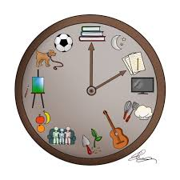
Routines
Classroom doors open at 8:45am
School starts at 8:50am
Morning break is 10.30am
Lunchtime starts at 11:30am

School finishes at 2:50pm
Being Healthy

A healthy snacks and a drink of milk will be provided each day.
Water bottles are allowed – no juice is permitted.

Water bottles are not to be brought into school, the children will be provided with paper cups if they need a drink at any time throughout the day.
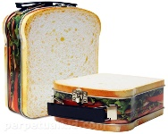

For the first few weeks in September a free healthy school packed lunch (not hot dinner) will be provided each day. If your child chooses to bring their own packed lunch it must be as healthy as possible and not include any fizzy drinks. The lunch must be brought in a disposable plastic carrier bag
We ask that for birthday celebrations, your child shares a book with the class to be kept in the class library. No treats are allowed due to school’s healthy status. We ask that you follow this rule. The children can wear non-uniform on their birthday only. If their birthday falls during the weekend they will not be permitted to wear their own clothes at school. Over the period of 7 years at school, this will be fair for all children.
P.E.

On PE day your child should wear their school PE kit to school and they will wear this throughout the school day so they do not need to change clothing during the school day. If the weather is cold they are able to wear jogging bottoms to school on these days. Your child will need to wear trainers NOT pumps.
Your child will need:
- School logo PE kits – royal blue logo t-shirt blue / black shorts
- Pumps
- Pump Bag
Please ensure your child’s name is on all PE kit items.


Please listen to your child read as much as possible, at least 3 times per week. Please comment on your child’s reading and let us know if they have completed the book. If your child’s reading record book has been signed 3 times or more per week their name will go on the reading star.
Reading / Homework
English Homework |  | Maths Homework
Reading / Key words | 15 mins daily | Number bonds  Doubles to 10/20  Halving | daily
Spellings | Weekly | Number bonds  Doubles to 10/20  Halving | daily
Each child is issued with a Times Tables Rockstar login which the children are encouraged to practise at home as well as complete in school.

From time to time, class teachers may give project homework on a topic such as: Your local area. This will be communicated to parents by letter if this is the case.

Each year group has specific words they need to learn. The Year 1 word list is:
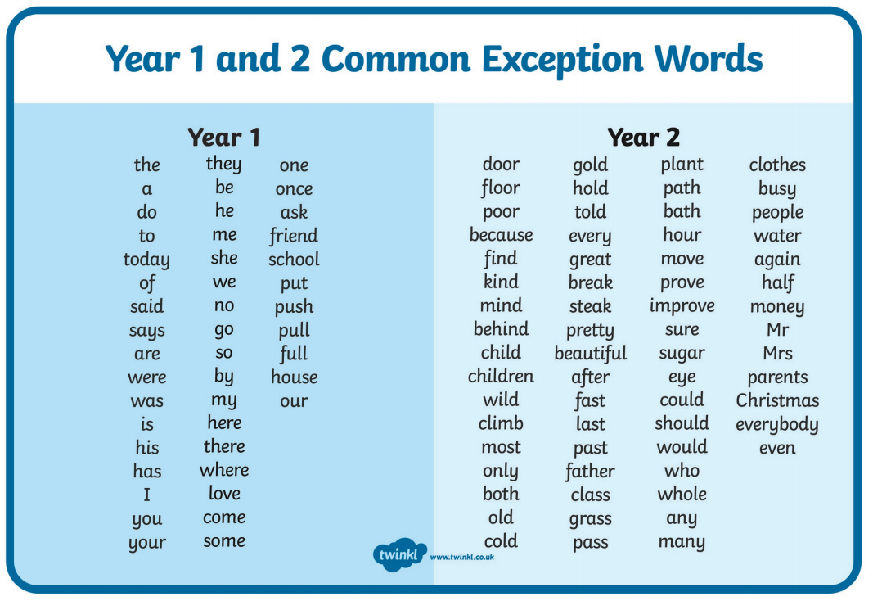
Handwriting
In Year 1 there will be formal lessons to teach the correct letter formation. Please encourage best handwriting in all work. After initial practise the children then will begin to learn joined up handwriting.

a b c d e f g h i j k l m n o p q r s t u v w x y z



Behaviour
We expect exceptional behaviour at all times and reinforce our rules and routines daily.

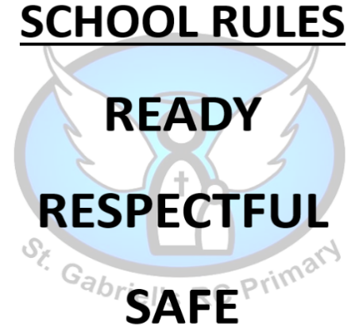
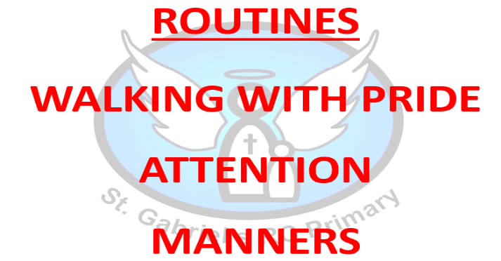

We encourage the children to learn from any poor behaviour choices they make.
For positive behaviour that goes above and beyond what is expected the children are rewarded with either:
Hot Chocolate Friday
Postcards/notes home
Phone calls home
Learning Behaviour
In school, we want the children to become responsible learners. We do this by promoting the following:
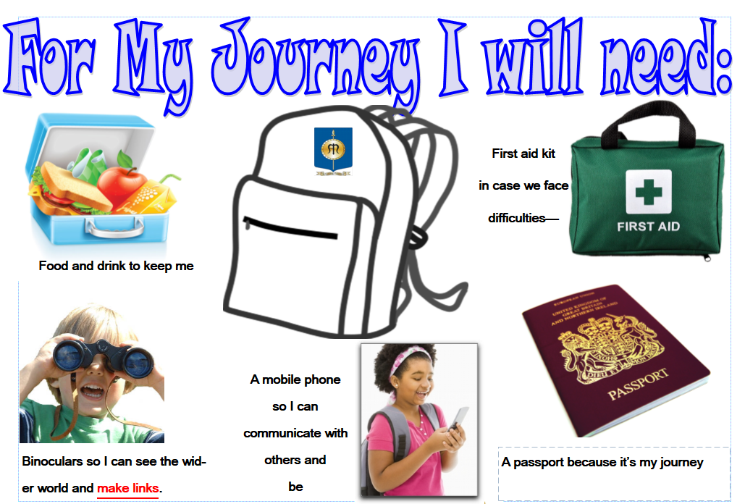

Uniform | - St. Gabriel’s School V collar sweatshirt or cardigan  - Grey trousers, grey skirt / pinafore dress  - White shirt  - Tie  - Black shoes, they can fasten (not trainers)  - Grey socks / white socks or grey / black tights  - Waterproof coat  - Hat/Scarf (winter) or sunhat (summer)  - Blue/white gingham dress in summer
Uniform – Optional Items | - Logo book bag  - School logo coat  - All weather suit
PE Uniform Indoor | - School logo PE kits – royal blue logo t-shirt blue / black shorts  - Pumps  - Pump Bag
PE Uniform Outdoor (KS2 only) | - Blue / Black jogging bottoms or leggings  - Blue / Black sweatshirt (no hoods)  - Trainers
Uniform
- Please ensure all clothing items have your child’s name in.
- Only watches and stud earrings to be worn. Studs are to be covered during PE and watches to be removed.
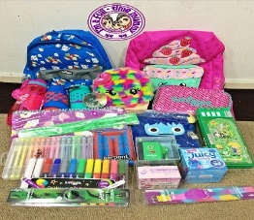
- Long hair must be tied up. No extreme hairstyles or large bows are permitted.
School Equipment
No bags, pencil cases, lunch boxes or other items from home are permitted within school – all equipment and stationery will be provided by school. This includes colouring materials, pens, pencils etc…
The only item to be brought in to school are coats and reading packs. Reading packs will be provided by school at the start of the academic year.
Drop Off and Collection
We advise only one parent drop off, between 8.45am to 9.00am and collect, 2.30pm to 2.40pm your child. Please encourage your child to be independent and prepared to hand in their reading books etc… themselves.
After School Clubs
Please notify the office in good time if someone else will be picks up.
There are a variety of after school clubs throughout the year across the school. For pupils in Year 1, the available clubs are:
Multi-skills on Monday - Further information will be sent out in a letter.

- Breakfast Club operates from 8:00 am – 8:50 am each weekday during term time only at a charge of £2.00.
Wrap Around Care / Before and After School Care
- After School Club operates from 2:50 pm—5:45 pm each weekday during term time only.
The charge for After School Club is as follows:
SESSION 1 - £3.00 (2.50 - 3.15 pm or 3.45 - 4.15 pm for late collection from extra-curricular clubs);
SESSION 2 - £5.50 (2.50 - 5.15 pm);
SESSION 3 - £6.50 (2.50 pm with collection between 5.15 - 5.45 pm).
Health and Safety

From a health and safety viewpoint it is very important that:
- long hair is tied up. No extreme hairstyles or large bows are permitted.
- your child does not bring in any toys from home
(unless directed by the class teacher);
- the trim trail is not used before and after school;
- smoking or vaping is not permitted on school premises;
- no dogs are permitted on school property
(including carrying the dog);
- you do not park on the school car park, block driveways
of school neighbours or park on the yellow lines.
This ensures the safety of all children.
Reporting Absence / Communication
If your child is going to be absent from school please leave a message on the school answering service on 01706 650280 leaving your child’s name, explain the reason for absence and when you expect your child to return to school.


Ways of communication with parents are via the parentmail app. Please ensure you download the app and set notifications to on. The school newsletter is sent out
every Friday via Parentmail. The newsletter can also be found on the school
website along with any other information you may need.
The school Twitter account is: @stgabscastleton. Please follow us.

Class teachers also communicate the children’s learning via Seesaw. This is an app you can download to follow your child’s learning. Ask the teacher for a QR code to get started.
School Trips
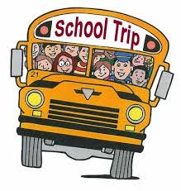
We want to enhance the children’s learning through school trips and other experiences such as visitors coming into school. Throughout the year your child may be selected to go on a school trip. We ask for a set contribution towards this to enable it to take place as school cannot afford to continually subsidise these opportunities. Therefore, if not enough money is received we may have to cancel the trip and monies will be lost.
Holidays in Term Time

We endeavour to stay open at all times because we want to make every day count. We can authorise absence for some, very rare circumstances but we cannot authorise absences for holidays. If you wish to go on holiday during term time this needs to be put in writing to the Headteacher. It is parents’ duty to have their child attending school and fines may be issued.

In Year 1 the government sets a Phonics Screening Check in the month of June. This is to assess the phonics knowledge of all the children across the country. The normal pass rate is 32 out of 40 although this is subject to change. There will be a parents’ meeting before the phonics check takes place so parents are aware of the standard of the test.
Learning for Life
Statutory Testing in Year 1
Each week your child will have the opportunity to learn skills in a group of their choice. This ranges from term to term. Please speak with your child to find out which group they have chosen.

Examples of groups include:
Gardening
Messy Science
Sports Leadership
Debate… to name a few.
Additional Needs
If you feel you child would benefit from provision over and above their current needs please speak with the class teacher.

The school SENDco is available to answer any questions you may have regarding any additional needs. The school works hard on providing a personalised programme of education and Pupil Passports are devised and reviewed termly with the class teacher, SENDco, parents and children. For more information regarding this, please speak with Mrs Brooks the Deputy Head and SENDco.
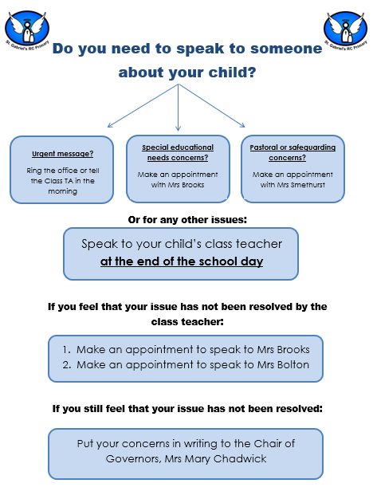
Speaking with Staff

This is a guide of what your child will be learning this year.
Year 1 Curriculum
Year 1 Curriculum Map 2020-2021
 | Autumn 1 | Autumn 2 | Spring 1 | Spring 2 | Summer 1 | Summer 2
Suggested High Quality Texts | The Night Pirate  (Recount) | Room on the Broom  (Recount) | Lost in the toy museum  (instructions)  (3wks)  Sams Sandwich  (Instructions)  (3wks) | The Queens Hat  (Diary) | Winnie Witch at the Seaside  (Postcards) | Little Red Riding Hood  (Letters)
Shared Reading | Tiddler | Room on the Broom | Jumblebum | The Queens Hat | Winnie the Witch | Little Red Riding Hood
Maths Follow White Rose Long Term Plan | Place value within 10  Number addition & subtraction within 10 | Geometry:  Shape  Number & Place value within 20 | Addition/subtraction within 20  Number place value within 50 | Measure, length and height  Measure weight and volume | Number, multiplication and division  Number fraction  Position and direction | Number place value within 100  Measurement: money  Measurement: time
Science | Seasonal Changes Autumn/Winter | Seasonal Changes Autumn/Winter | Materials | Animals Inc. Humans | Plants  (Beans) | Seasonal Changes Spring/summer
Creative Curriculum  History / Geography | The History of me!  Titanic  Christopher Columbus  maps | Florence Nightingale / NHS  Maps | Toys  Our local area | Geography  Our Four countries and capital of UK | Seaside | Geography
Art / D&T | Design a Pirate lunch box  St Gabriel’s Day  Self Portrait  Design a ship (HW) | Firework art  Christmas  Artist Wassily kindinsky-Calendars | Design a fabric face Puppets  Great Bread Bake off  Draw picture of toys | Create a hat fit for a Queen.  Design your own fantasy animal and habitat. | Draw flowers | Moving Pictures Traditional tales
Computing | 1.1 we are treasure hunters  Seesaw –  E-safety, importance of things going online | 1.2 We are TV chefs | 1.3 We are painters | 1.4 We are collectors | 1.5 We are storytellers  PIC collage | 1.6 we are celebrating
Religion | Domestic Church  : Families/myself | Baptism: Belonging  Advent | Local Church: special people  Eucharist: meals | World faiths  Lent/Easter | Pentecost  Reconciliation | Reconciliation  Universal church
P.E. | Gymnastics | Dance | Basic Skills | Gymnastics | Dance | Games
Enrichment | Reading corner: Pirate  Visit to Build a bear  Visit from IO as hot seating pirate  Party | Reading area: Space/ travel/ Christmas stories  Middleton Arena – Theatre Trip  (Whole School)?  Visit to St Gabriel’s Church for Baptism  Visit to Pizza Express  Nativity performance | Reading area: Toy books/ Healthy eating  Touch stones Old Toys box | Reading area: Animal stories/ non fiction animals  Visit to St Gabriel’s Church | Reading area: seaside/holiday  Touchstones  Holidays Loan Box  Visit to beach (St Annes)  Visit to the beach | Reading area: Traditional stories

Non Negotiables Year 1
Unlocking learning through oracy
• Speak clearly and loudly enough to communicate meaningfully.  • Ask questions about matters of interest.  • Express feelings and ideas when talking about matters of interest.  • Start to develop ideas by adding detail to their speech.  • Start to understand how to take turns when speaking.  • Start to listen to others and respond appropriately. |  | • Join in with imaginative play taking on role of different familiar characters.  • Speak in complete sentences after modelling.  • Retell a familiar story in sentences, using narrative language.  • Recount an event or experience in sentences.  • Begin to understand how to change language when speaking to different listeners, e.g. peers and adults.
Reading | Writing |  | Mathematics
- Secure with year group phonic expectations.  - Identify which words appear again and again.  - Recognise & join in with predictable phrases.  - Relate reading to own experiences.  - Re-read if reading does not make sense.  - Re-tell with considerable accuracy.  - Discuss significance of title & events.  - Make predictions on basis of what has been read.  - Make inferences on basis of what is being said & done.  - Read aloud with pace & expression, i.e. pause at full stop; raise voice for question.  - Recognise:  capital letters  full stops  question marks  exclamation marks  ellipsis  - Know why the writer has used the above punctuation in a text.  - Know difference between fiction and non-fiction texts. | - Write clearly demarcated sentences.  - Use ‘and’ to join ideas.  - Use conjunctions to join sentences (e.g. so, but).  - Use standard forms of verbs, e.g. go/went.  - Introduce use of:  capital letters  full stops  question marks  exclamation marks  - Use capital letters for names & personal pronoun ‘I’.  - Write a sequence of sentences to form a short narrative [as introduction to paragraphs].  - Use correct formation of lower case –finishing in right place.  - Use correct formation of capital letters. |  | - Count to & across 100, forwards & backwards from any number.  - Read & write numbers to 20 in numerals & words.  - Read & write numbers to 100 in numerals.  - Say 1 more/1 less to 100.  - Count in multiples of 2, 5 & 10.  - Use bonds & subtraction facts to 20.  - Add & subtract:  1 digit & 2 digit numbers to 20, including zero.  - Solve one-step multiplication & division using objects, pictorial representation and arrays.  - Recognise half and quarter of object, shape or quantity.  - Sequence events in chronological order.  - Use language of day, week, month and year.  - Tell time to hour & half past.
We are very lucky that we have a French and Music specialist who work with the children each week.

Mrs Reynolds teaches music throughout the school

Madame Beer teaches French in KS2 and takes small groups in KS1.


