Florence Nightingale
Key Vocabulary
founder | A person who starts something.
lamp | A kind of light.
patient | Someone who is unwell or injured and needs to be looked after.
soldier | Someone who serves in the army.
1837
Florence felt God call her to serve Him, she campaigned for better care in the hospitals.

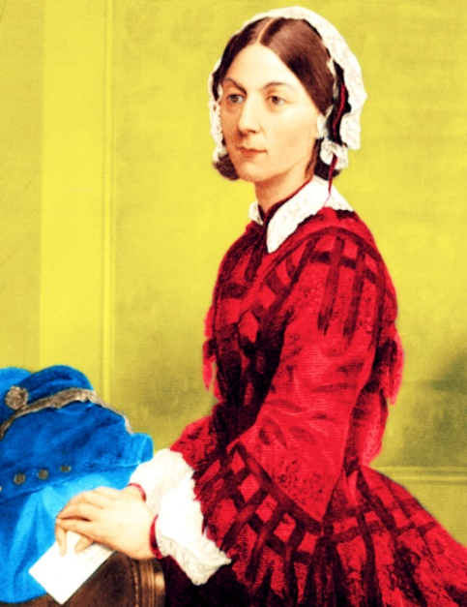
1853
Florence became a superintendent at a medical centre for women in London.
The Crimean War broke out and lasted till 1856.

1851
Florence became a nurse and helped soldiers who were hurt in the war.
1854
Florence went to Turkey to care for wounded soldiers.
Florence made sure the hospitals were clean and she saved many lives.
Florence was names ‘Lady of the Lamp’ as she cared for people through the night with a lamp in her hand,

1820
Florence Nightingale was born on the 12th May 1820 in Italy. She was named Florence after the town she was born in. When Florence grew up she became a nurse.
Florence Nightingale is known as the
‘Lady of the Lamp’
because she carried a lamp with her when she checked on her patients in the night.

Facts
Before Florence Nightingale, hospitals were overcrowded and there were not enough beds. Hospitals were dirty and had rats and there weren’t enough doctors to help the patients. Florence Nightingale showed that trained nurses and clean hospitals could help sick people to get better.
Because of this she is called the founder of modern nursing.

1855
People give lots of money to the Nightingale Funds for the training of the nurses.

1857
Florence returned to England as a heroine.

1859
The Nightingale training School was opened.

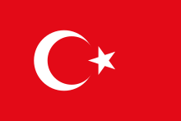
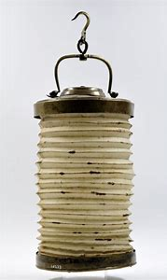
Florence Nightingales lamp.
1883
Queen Victoria awarded Florence
‘The Royal Red Cross’

Turkish flag

1896
Florence became so ill she could not leave her bed.

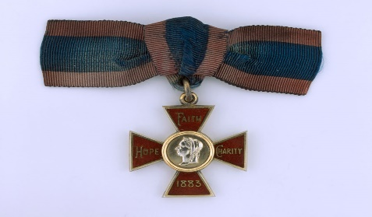
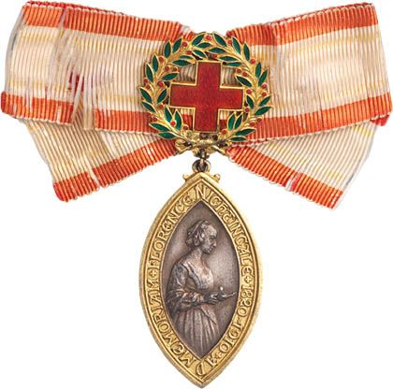

1907
Florence was awarded ‘The Order of the Merit’
Florence Nightingale dies on the 13th August 1910 aged 90.

The Royal Red Cross
The Order of Merit

