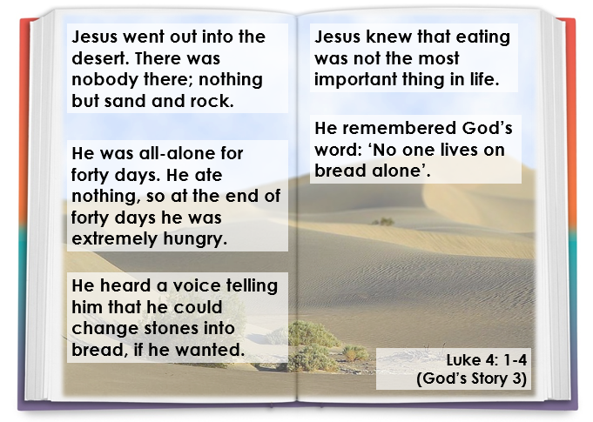
Friday 10th March 2023
Focus: Lent – Jesus’ thoughts and words



