Reception Literacy Overview
Autumn 1 | Settling in |  |  |  |  | Marvellous Me
 | Wk 1 5/9 |  | Wk 2 12/9 |  |  | Wk 3 19/9 | Wk 4 26/9 |  |  | Wk 5 3/10 | Wk 6 10/10 | Wk 7 17/10
Core Texts | Marvellous Me-Bullard  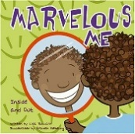 |  |  |  |  | Owl Babies - Waddell  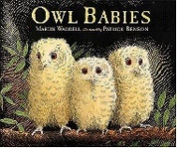 |  |  | Peace at last – Murphy 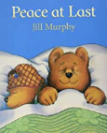 |  | The Gruffalo – Donaldson  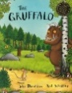
Wrap around texts  RfP | Wonkey Donkey – Smith & Cowley  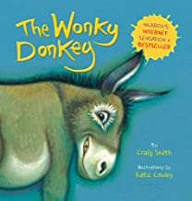  The Colour Monster goes to school -Llenas  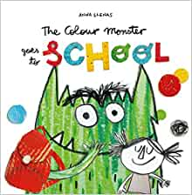  Hugless Dougless goes to little school-Melling  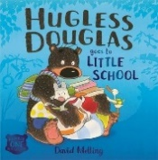 |  |  |  |  | The Owl who was afraid of the dark - Tomlinson  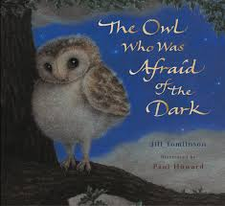  Once there were Giants – Waddell  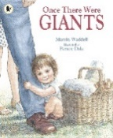 |  |  |  |  | Only one you – Kranz  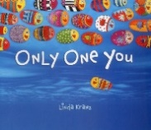  https://www.youtube.com/watch?v=VrYvuYwPAvU  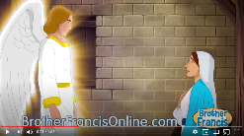
Writing Outcome | Baseline Writing – Sounds, Name |  |  |  |  | Speech bubbles – Mark making and giving meaning to marks  WRITING – St. Gabriel’s message  Missing poster  Instructions |  |  |  |  | Assessment – join in with familiar phrases, characters, retell and rhyme.  & Sunshine Day
1 RfP  2 Provision  3 Topic | The story of the little mole who knew it was none of his business – Holzworth & Erlbruch  The rhyming rabbit – Donaldson  Frog on a log – Cox and Cartwright  Ready, set, build – Fleming  My feelings - Bloomsbury  The New Baby – Usborne  So Much – Cooke  Heads, shoulders, knees and toes…  If you’re happy and you know it…  See-saw - Busby  All kinds of bodies – Brownjohn
Autumn 2 | Autumn |  |  |  |  | Out of this World |  |  |  | Jingle All the Way
 | Wk 31/10 |  | Wk 2 7/11/ | Wk 3 14/11 |  | Wk 4 21/11 |  | Wk 5 28/11 |  | Wk 6 5/12 | Wk 7 12/12
Core Texts | Rama and Sita – Doyle  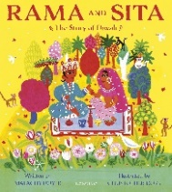 | Leaf Man – Ehlert  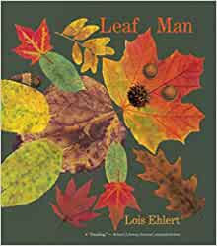 |  | The Smeds and the Smoos – Donaldson  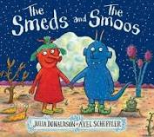  The dinosaur that pooped a planet! – Fletcher  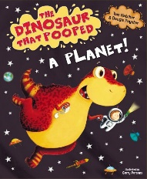 |  |  |  | Space – Arlon  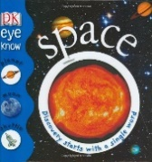  On the moon – Milbourne  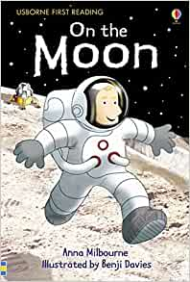 |  | 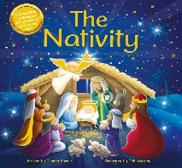  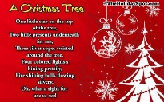  A Christmas Tree - Anon | 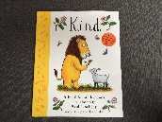  Kind – Scheffler  https://www.youtube.com/watch?v=sUGKKQ9gFDY  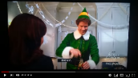
Wrap around texts | Recipe – Diwali Sweets  Cbeebies  https://www.youtube.com  /watch?v=KZU6M4EisyA  Diwali – Festival of light song |  |  | Aliens Love Underpants – Freedman  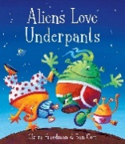  The last tree in the city – Carnavas  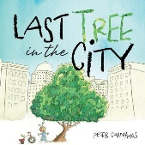 |  | Marshmallows for Martians - Guillain  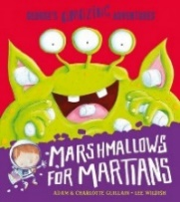  In Space – Evans  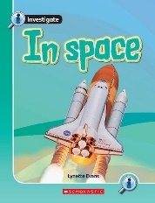 |  | The Elves and the Shoemaker - George  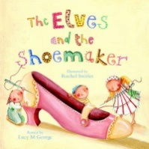  Mince Spies-Sperring  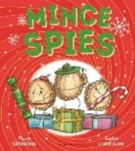 |  | The Nativity -Watt  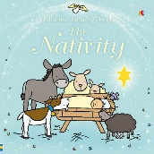 | We’re going on an Elf chase – Mumford  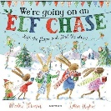  We’re going on a baby hunt – Anon
Writing Outcome | Labels  List |  | Labels Speech Bubble | Description |  | Sequence/  Sort |  | Fact File |  | Sentence/list Number/List poem | Christmas Card
1 RfP  2 Provision  3 Topic | Water, Water –Greenfield  A Christmas Story - Wildsmith  One shoe Two Shoes – Hart & Underwood  Anno’s Counting Book  My feelings – Bloomsbury  Five little men in a flying saucer – Crisp  Internet – Owl Facts  Aliens in underpants save the world – Freedman  Space Poems – Morgan  Kipper’s Birthday –Inkpen  The Gingerbread Man – Youtube linkhttps://www.youtube.com/watch?v=jv4k8b9b4G8  Ketchup on your reindeer – Sharratt  Hoot owl, master of disguise – Taylor  Space – Priddy and Powell  The solar system - Bone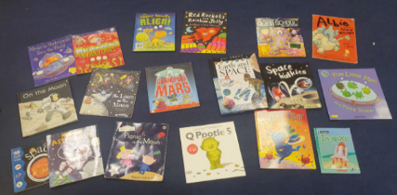
Spring 1 | Real Life Superheroes |  |  |  |  |  |  | Aspirations
 | Wk 1 3/1 |  | Wk 2 10/1 | Wk 3 17/1 |  | Wk 4 24/1 |  | Wk 5 31/1 |  | Wk 6 7/2 | Wk 7 14/2
Core Texts | Supertato – Hendra & Linnet  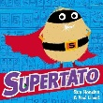 |  |  |  |  | The enormous turnip - |  | The Barnabus Project – The Fan Brothers  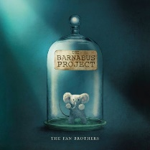
Wrap Around Texts | Supertato, books are rubbish – Hendra & Linnet  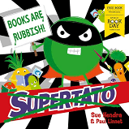 |  | Thank you Heroes – Hegarty  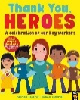 |  |  | Recipe?  Healthy Eating - Head  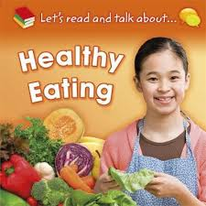 |  | Zoe and Beans – Inkpen  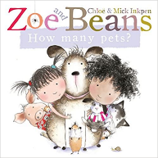  How much is that doggy in the window ?    https://youtu.be/NIaAHqwTc8g  Clever dogs:    https://youtu.be/z0Tz1pcF7I8  Trailer from Pooch Perfect    https://youtu.be/njydexJaggk |  | That’s not my puppy … Watt  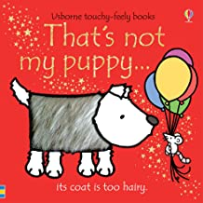  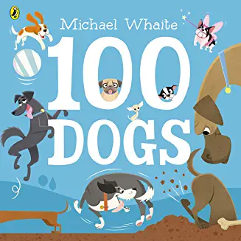  100 dogs – Whaite
Writing Outcome | Speech Bubbles/Captions |  | Wanted Poster | Narrative |  | Advert |  | Recipe/  Instructions |  | Poem | Sentence.
1 RfP  2 Provision  3 Topic | Olivers Vegetables – Bartlett & French  The very Hungry Caterpillar – Carle  Atlas - Baker |  |  |  |  |  |  |  |  | When I grow up –  Minchin & Antony  Song from Matilda  Snail Mail-Chai | The world made a rainbow - Robinson
Spring 2 | Growth & Change |  |  |  |  |  |  | Easter
 | Wk 1 28/2 |  | Wk 2 7/3 | Wk 3 14/3 |  | Wk 4 21/3 |  | Wk 5 28/3 |  | Wk 6 4/4 | Wk 6 11/4  (3days)
Core Texts | Jack and the beanstalk – Kelly  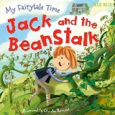 |  |  | Egg to chicken -Tonkin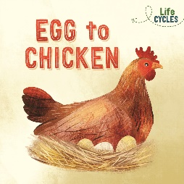  Life cycle of a Chicken-Holmes  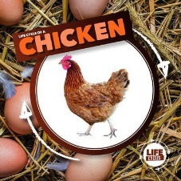 |  |  |  | The Easter Story – John  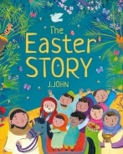  Elaine’s books-
Wrap Around Texts | The Tiny Seed-Carle  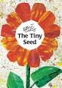  The Tin Forest - Ward  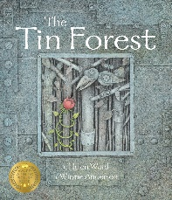 |  | Bean –Holmes  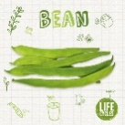 | Jaspers Beanstalk - Butterworth 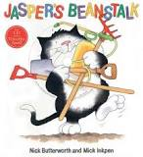
Writing Outcome | Instructions |  | Story map New character | Story ending |  | Life cycle captions |  | Captions |  | Captions | Easter Card
1 RfP  2 Provision  3 Topic | Jack & The Beanstalk performance Songs – Davies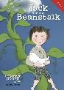  Hattie Peck - Levey
Summer 1
 | Wk 1 25/4 |  | Wk 2 2/5 | Wk 3 9/5 |  | Wk 4 16/5 |  | Wk 5 23/5
Core Texts | Oi Frog – Gray  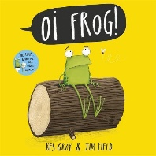 |  |  | Superworm –Donaldson 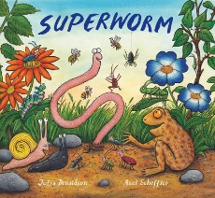 |  |  |  |  |  | Bog Baby - Willis  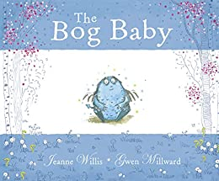
Wrap Around Texts | Tadpoles Promis – Willis  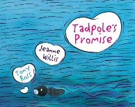 |  |  |  |  | Frogs – Gaffney    Tadpoles and Frogs-Feldman  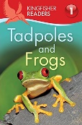 |  | Billy’s Beetle - Inkpen 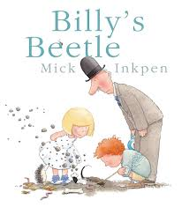 |  | Bird house –Walden  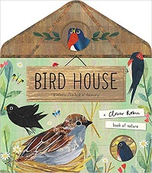
Writing Outcome | Rhymes |  | Alliteration  Poem |  | Fact File/Life cycle | Diary |  | Diary |  | Character description | Report
1 RfP  2 Provision  3 Topic | Very Busy Spider- Carle  Animal rhymes – Ross  We’re going on a lion hunt – Axtell
Summer 2
 | Wk 1 13/6 |  | Wk 2 20/6 | Wk 3 27/6 |  | Wk 4  4/7 |  | Wk 5  11/7 |  | Wk 6  18/7  (4 days)
Core Texts | The Lighthouse Keepers Lunch - Armitage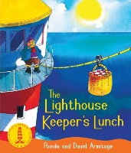 |  |  |  |  |  |  | Creature features, Oceans – Durley  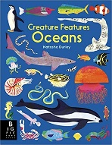  Ocean - Anon 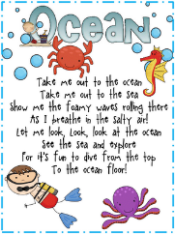
Wrap Around Texts | Tiddler – Julia Donaldson |  |  |  |  | Life on Earth – Heather  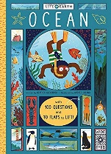 |  | Coral Reef – Priddy & Parker  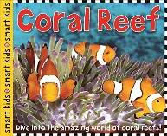
Writing Outcome | Labels |  | Captions | Narrative |  | Poem |  | Leaflet or recount?
1 RfP  2 Provision  3 Topic | The Rainbow Fish – Pfister  How to catch a mermaid – Wallace  Sharing a shell – Donaldson  The Lighthouse keeper - https://www.youtube.com/watch?v=yo4rD9NvO5M  Lighthouse - https://www.youtube.com/watch?v=6HfBbSUORvo  Lighthouse working- https://www.youtube.com/watch?v=xxX36GEAJn4

