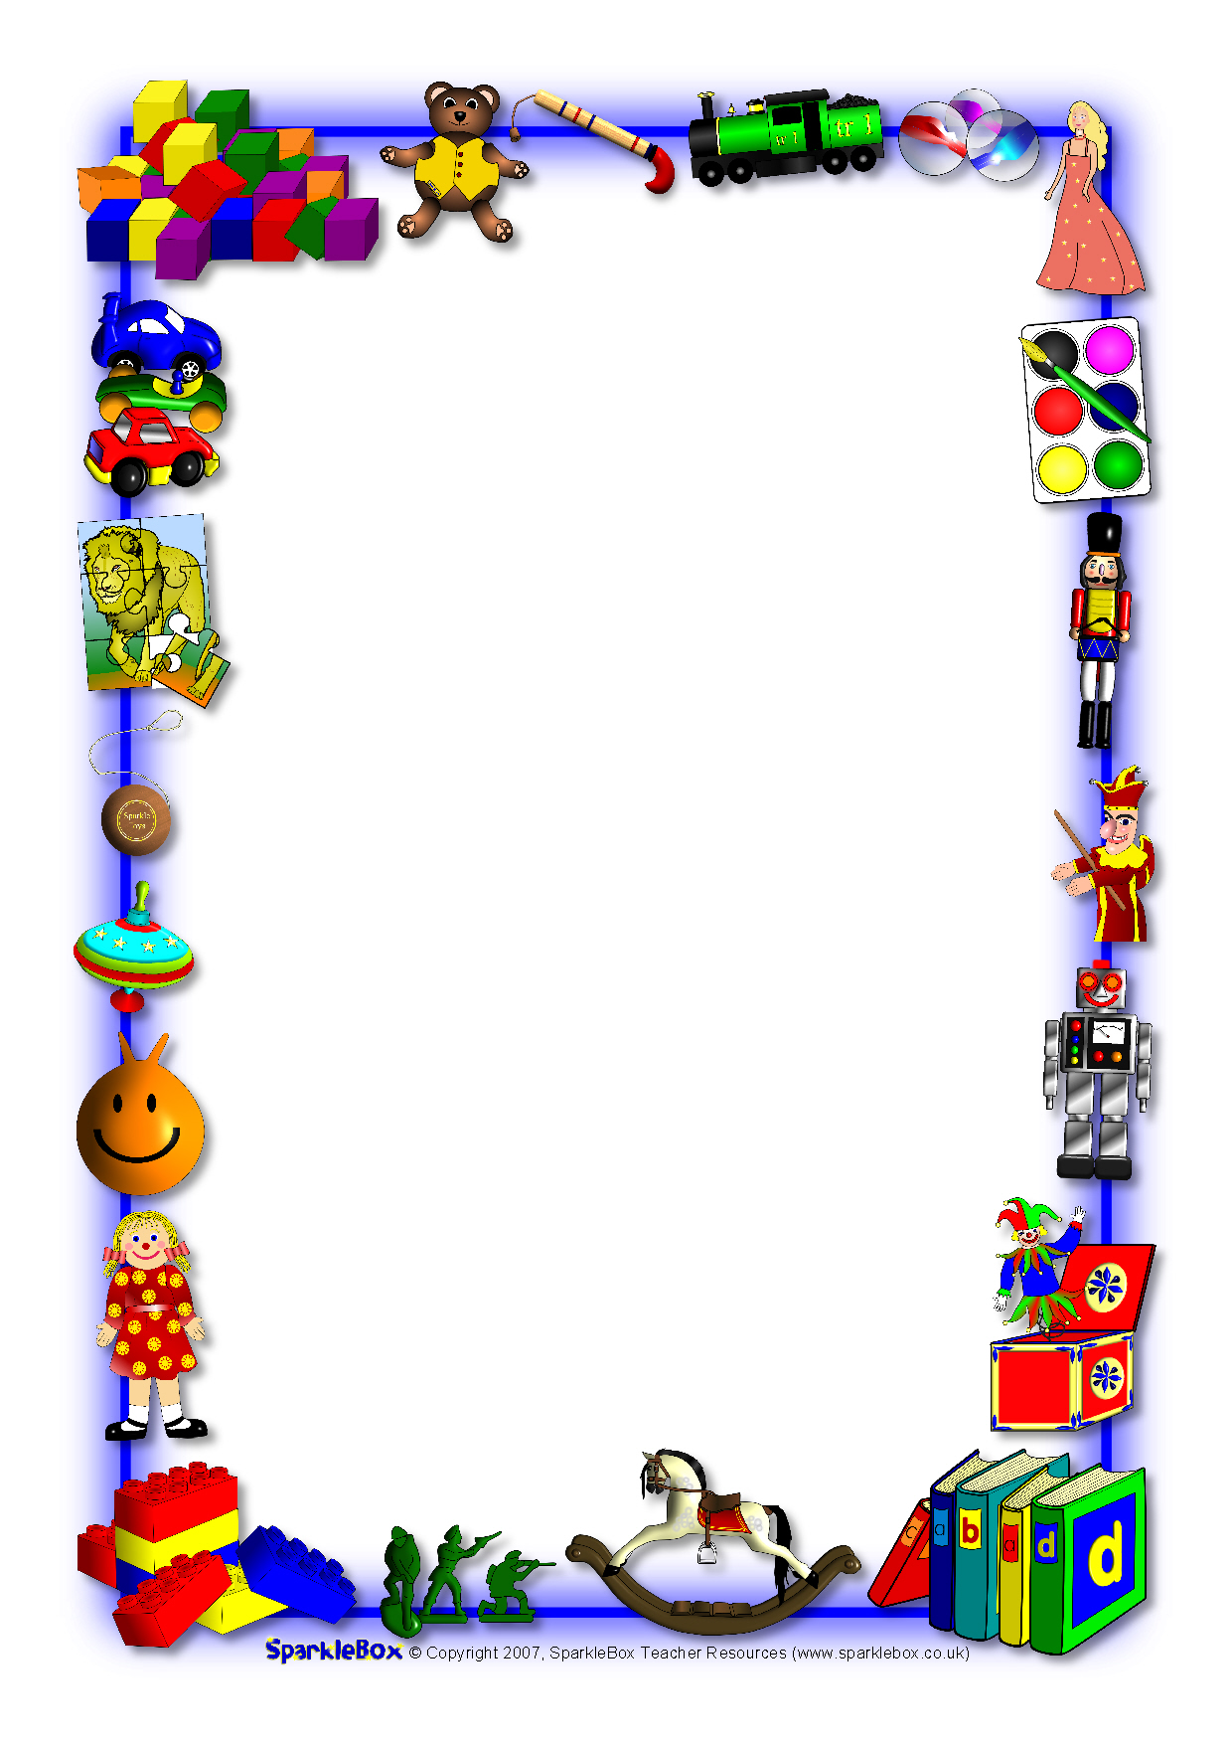


You have six weeks to complete your project. It must be handed in by Wednesday 25th October.
You must complete at least one challenge from each section—at least three challenges in total.
Work may be presented in any way you wish.
Upon completion of your project your work will be graded gold, silver or bronze.
Effort, content and originality will all be considered.
Starter
Can you research what toys people used to have in the past?
Ask an adult what their favourite toy was when they were young. Draw their favourite toy and your favourite toy. How are they the same? How are they different?
Main
Can you describe and write about your favourite toy?
Can you draw a picture of a toy and label all the different parts?
Dessert
Can you design and create a toy out of junk modelling materials?
Can you create a collage picture of toys?

