
You have six weeks to complete your project. It must be handed in by Wednesday 20th December. You must complete at least one challenge from each section—at least three challenges in total. Work may be presented in any way you wish.
Upon completion of your project your work will be graded gold, silver or bronze. Effort, content and originality will all be considered.

What is the Gunpowder Plot?
Year One Home Learning Tasks

Dessert Task 5 – Can you make a creative firework picture? You can use any art media you like e.g paint, chalk.
Task 6 - Can you make your own model of a ‘Guy Fawkes’?
Main Task 3 – Can you design a fire safety poster to keep people safe on bonfire night? Task 4 – Can you write an extra verse for the famous bonfire night poem? 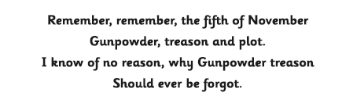
Starter Task 1 – Can you research Guy Fawkes and the Gunpowder plot? You could go to the library or use the internet. Create a fact file to show what you know.
Task 2 - Can you write a letter to the public warning them not to go near the houses of Parliament on the 5th of November?

