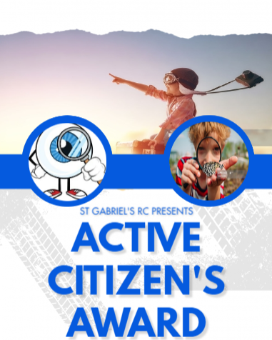
RECEPTION
Activity |  |  | Date
1 | Learn home address in case of emergency??
2 | Use cutlery
3 | Using manners – please, thank you, may I…
4 | Understanding ‘no'
5 | How to share
6 | How to brush your teeth properly
7 | How to put things back
8 | Understanding ‘good touch’ and ‘bad touch’
9 | Recognising who is in their circle of trust
10 | Taste a new fruit/vegetable
11 | Use a dust pan and brush
12 | Turn clothes the right way
13 | Put shoes on the correct feet
14 | Zip a coat up
15 | Stamina to run around the yard
16 | Open food packets/Use a bendy straw

EXPLORER

