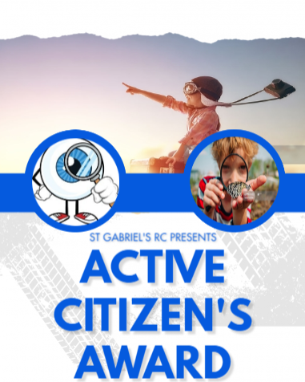
RECEPTION
Activity |  |  | Date
1 | Fasten buttons / zips on coats
2 | How to make a sandwich (spreadable)
3 | Learn home address
4 | How to ask questions to get to know a friend better
5 | How to take care of plants
6 | How to complete simple tasks without reminders i.e. bring school reading wallet, tidy pots away, make bed, put dirty clothes in washing basket
7 | Learn an important phone number in case of an emergency
8 | Speak / read out loud to class or audience
9 | Recognising healthy and unhealthy food options
10 | How to wash your face including neck and behind ears
11 | Use knife and fork
12 | Turn a clothes item from inside out
13 | Make a home for an insect or small creature
14 | Borrow a book from the library
15 | Make a daisy chain

PIONEER

