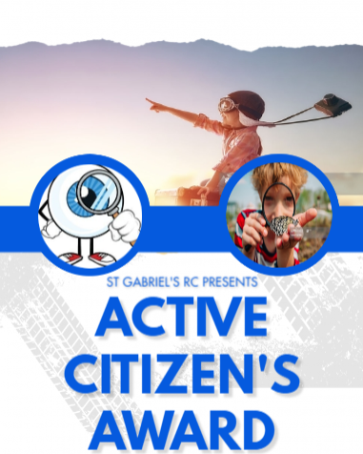
Activity |  |  | Date
1 | What to do in an emergency - 999
2 | Tie a shoe lace
3 | How to accept being told no
4 | How to apply a plaster
5 | How to interact with adults
6 | How to tidy up after themselves
7 | How to behave in public places, e.g. restaurants, cinemas
8 | Understanding ‘my body, my rules’; not to be asked to keep secrets about their body
9 | How to protect yourself in the sun
10 | Understand the importance of being active
11 | Play a board game e.g snakes and ladders
12 | Learn a short poem off by heart
13 | Buy something and check your change
14 | Dress up as a superhero
15 | Walk barefoot on the sand or on a nature trail

RECEPTION
VENTURER

