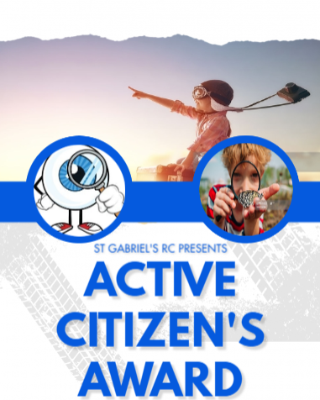
Activity |  |  | Date
1 | How to make toast
2 | Understanding nutritional information on food packages
3 | How to wash hair
4 | Understanding who may say ‘no’
5 | How to cross the road safely
6 | How to wash up
7 | How to understand other people’s perspectives
8 | How to cope with failure
9 | How to type on a laptop/computer
10 | How to trim their nails
11 | Visit the theatre
12 | How to travel via train to Manchester
13 | How to tie shoe laces
14 | How to write, and then send, a birthday card
15 | How to start, and continue, a conversation
16 | Understand about FIRE safety

RECEPTION
DEVELOPER

