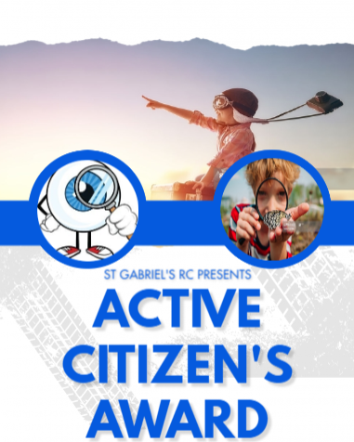
RECEPTION
Activity |  |  | Date
1 | How to change batteries
2 | How to clean a wound
3 | How to change a light bulb
4 | How to tie hair up
5 | How to act when you hear ‘no’
6 | How to recognise emotional reactions and what to do
7 | How to be safe near water
8 | How to ask for help – agencies
9 | How to grow your own vegetables
10 | How to make a sculpture with clay
11 | Visit a Museum
12 | Make up a game and teach it to someone
13 | Go on a treasure hunt
14 | Take part in a debate
15 | How to make a simple soup
16 | Understand about WATER safety

ADVENTURER

