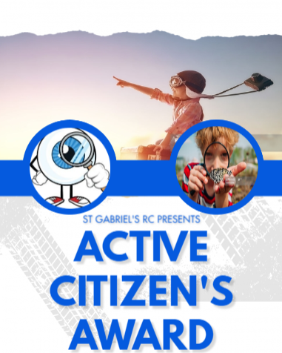
Activity |  |  | Date
1 | Making a hot drink
2 | How to plait hair
3 | Understanding why no is important
4 | How to wrap a present
5 | How to give someone the benefit of the doubt
6 | Know simple CPR steps
7 | How to use a screwdriver
8 | How to use a hammer
9 | How to cycle safely
10 | How to make themselves feel better
11 | How to pitch a tent
12 | How to make an nutritious evening meal
13 | How to exercise using your body weight
14 | How to tell the difference between a good friend and a bad friend
15 | How to keep your room clean
16 | How to communicate clearly  (how messages and/or online texting can be misconstrued)
17 | Understand about ROAD safety

RECEPTION
TRAILBLAZER

