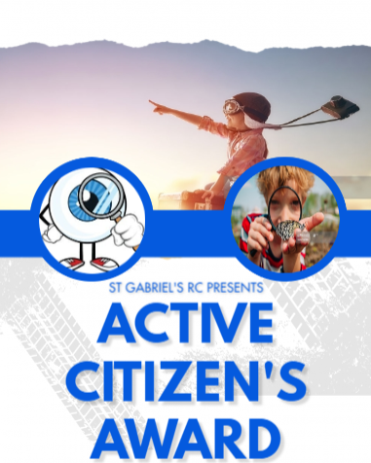
Activity |  |  | Date
1 | Tie a tie
2 | How to use a washing machine
3 | Recovery position
4 | How to change a fuse
5 | Understanding consent and the term ‘no’.
6 | How to make your bed
7 | How to manage money and budget
8 | How to interact with new people
9 | How to sew (a bag)
10 | How to respect people
11 | How to deal with peer pressure
12 | How to tackle anti-social behaviour
13 | How to write an email
14 | Being comfortable with themselves/body image
15 | Teamwork, resilience, confidence (Residential visit)
16 | Understand about RAILWAY safety

RECEPTION
LEADER

