

5 useful Apps to support children’s mental health and well-being.
Visit your app store to search for and download the following apps:
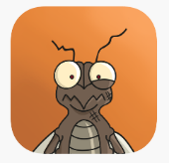

- Mindful Gnats - Mindfulness and relaxation skills
- Mindshift – To help you cope with anxiety

- Rise Up + Recover – Support if you are struggling with an eating disorder

- SmilingMind – Modern meditation for young people aged seven years and above

- SuperBetter – Help to increase your resilience to deal with the challenges in life

