Where can you get help?
Firstly, speak to someone you trust, like a friend, family member, teacher or school counsellor. Opening up is the first step towards good mental health. Once you have spoken to someone it’s easier to find the best way to make you feel better.
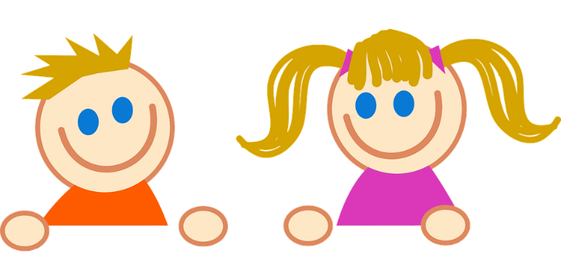
There are also lots of helplines and websites that are there for talking to people about mental health!
If you want more information about mental health, visit the websites below:
- http://www.samaritans.org/
- https://www.childline.org.uk/
- https://youngminds.org.uk/
If you believe you or someone you know is suffering with mental health problems, you can ring one of the helplines below to talk to a professional:
- Samaritans helpline: 116 123
- Childline helpline: 0800 1111


What should you do if you’re worried about a friend or family member’s mental health?
Talking about mental illness is the first step to feeling better. If you think someone you care about might be having problems with their mental health, try talking to them about how they are feeling.

Sometimes it is difficult for people to talk about mental health, so try to pick a good time and somewhere quiet to talk. Ask how they are feeling and what advice or support they think they need.
Once someone has opened up to you, you can help by:
- Spending time with them.
- Talking through their problems with them to help find a solution.
- Telling them you are there for them.
- Helping them with any therapy they are having.

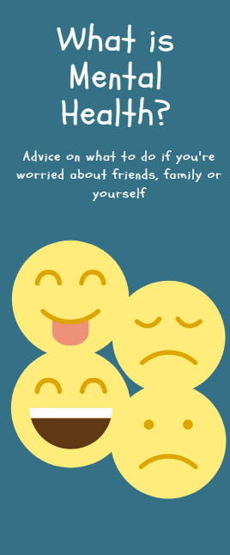

What is ‘mental health’?

When we talk about ‘mental health’ we mean our thoughts and feelings, and how we use them to cope with difficult things in our life.

This can mean:
- Our feelings about ourselves and people around us.
- Our ability to make friends and keep relationships going.
- Our ability to learn from others to develop our emotions and our ways of thinking.
It is about our confidence, self-esteem and belief in ourselves.
Why is mental health important?
For our bodies to be fit and healthy, we have to do things to look after them, like eat, drink and exercise.
It is just as important to keep our minds healthy, because our mental health can affect our moods, how we think and feel about things, and how we deal with problems.
Our mental health can even affect our physical health; it can make us feel well or ill.
What is mental illness?
Mental illness is something that can happen when our mental health becomes unwell, in fact, it happens to 1 in 10 young people.

There are lots of different types of mental illness with different symptoms and different treatments.

How can you spot mental illness?

Different types of mental illness will show themselves in different ways, but common signs include the following:
- Feeling sad or down
- Being confused
- Finding it difficult to concentrate
- Feeling scared, angry, worried or guilty a lot of the time
- Having trouble sleeping or feeling tired all the time
- Feeling like you can’t cope with things you usually could
- Avoiding friends and purposely being alone
How can you look after your mental health?
Some ways to look after your mental health, to help cope with feeling stressed or anxious, include:
- Talking to someone you trust about any problems you are having – this could be a friend, family member or teacher.
- Letting people know how you are feeling.
- Exercising and taking part in activities – this could be yoga, dance, football, whatever you enjoy!
- Making time to relax in a way you enjoy – this could be singing, writing, reading, watching TV, meditating, listening to music or other hobbies.
- Planning time to do things you like.
- Eating a balanced diet.
If you find that feelings of sadness or stress are stopping you from carrying on with your usual life, and that this lasts a long time, you should talk to someone you trust.

Don’t suffer in silence! Remember that no matter how down you are feeling, there are always people to talk to who care about you!

