

Reception
Information for Parents

This booklet is intended to give families an overview of the Reception timetable, routines and other specific information to Reception. Your child will need to familiarise themselves with the new routines in September so please read this booklet together.
Teaching Staff
Welcome to Reception
The Reception teacher for this year is:

To Be Confirmed
The teaching assistant who will be working with the children in class are:
 Miss. R. Leyland
Routines

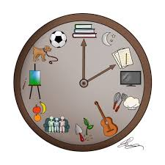
Classroom doors open at 8:45am – 8:50am
Lunchtime starts at 11:30am
School finishes for collection 2:50pm
Being Healthy


Only healthy snacks are allowed during snack times, these are provided through the free fruit scheme.
Water is provided in school and bottles are not permitted to be brought in from home.

.

Packed lunches are to be as healthy as possible and not include any fizzy drinks.
We ask that for birthday celebrations, your child shares a book with the class to be kept in the class library or brings in a small token item for their friends e.g a pencil. No treats are allowed due to school’s healthy status. We ask that you follow this rule. The children can wear non-uniform on their birth-day only. If their birthday falls during the weekend they will not be permitted to wear their own clothes at school. Over the period of 7 years at school, this will be fair for all children.
P.E.
PE lessons in Reception are on: TUESDAYS (Subject to change - Physical activities are encouraged throughout the week both indoors and outdoors to work on fine and gross motor skills.)
Children will come into school dressed for P.E. on their particular day. This will commence during the 2nd half term after the children have settled in.
Your child will need:

- School logo PE kits – royal blue logo t-shirt blue / black shorts.(Jogging bottoms for colder days).
- Trainers instead of pumps for outside (please ensure Velcro fastening if your child cannot tie their own laces)
- Please ensure your child’s name is on all PE kit items.
Please listen to your child read as much as you can, daily where possible. Please comment on your child’s reading and let us know how many pages they’ve read or if they have completed the book by signing in their reading diary.
Reading / Homework
English Homework |  | Maths Homework
Reading / Key words | 15 mins daily | Oral counting, recognising patterns, number bonds work.  Maths based activity | Daily  Weekly
Phonics sounds/Handwriting | weekly |  | Daily  Weekly
Each child is issued with a Times Tables Rockstar login which the children are encouraged to practise at home as well as complete in school(This is for learning multiplication facts-Not needed at the start of Reception.
From time to time, class teachers may give project homework on a topic such as: The Romans. This will be communicated to parents by letter if this is the case.
Each year group has specific words they need to learn. Reception focus on these high frequency words:
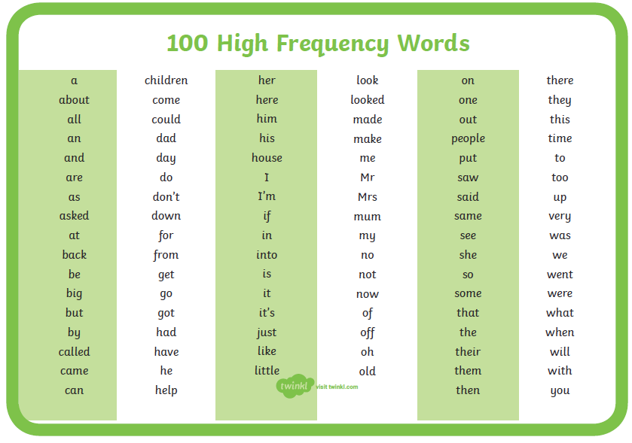
Handwriting
As we learn each of the letter sounds in phonics, children will be taught how to form the letters accurately. Formal lessons for handwriting will begin in year 1 and children are taught to join. Please encourage best handwriting in all work.

We expect exceptional behaviour at all times and reinforce our rules and routines daily.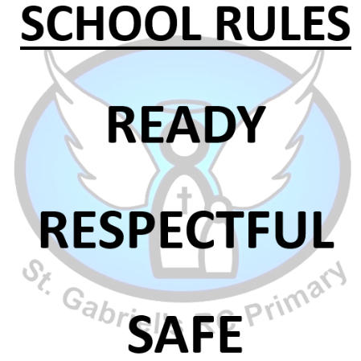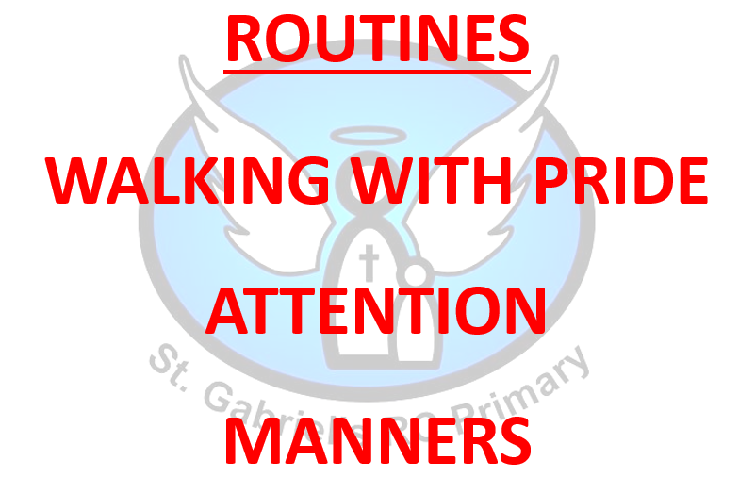
Behaviour
We encourage the children to learn from any poor behaviour choices they make.
For positive behaviour that goes above and beyond what is expected the children are rewarded with either:
Hot Chocolate Friday
Postcards/notes home
Phone calls home
Learning Behaviour
In school, we want the children to become responsible learners. In Early Years, these are called the Characteristics of Effective Learning. We do this by promoting the following:

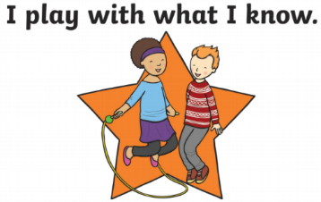

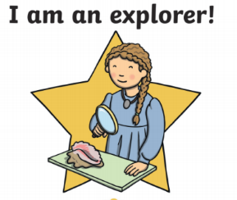
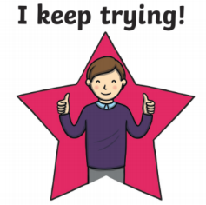

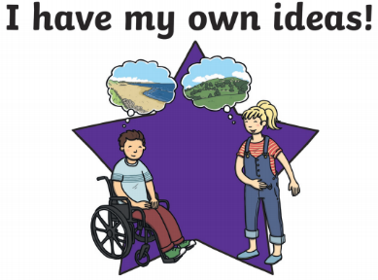




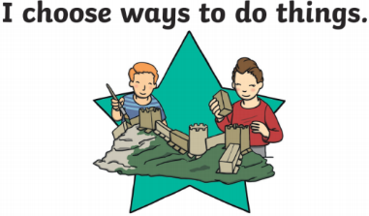

Uniform  Bag- Your child will receive a reading pack to carry their books. This is the only bag allowed in school. | - St. Gabriel’s School V collar sweatshirt or cardigan  - Grey trousers, grey skirt / pinafore dress  - White shirt  - Tie (Optional for reception)  - Black shoes, they can fasten (not trainers) –Wellington Boots essential in EYFS  - Grey socks / white socks or grey / black tights  - Waterproof coat  - Hat/Scarf (winter) or sunhat (summer)  - Blue/white gingham dress in summer
Uniform – Optional Items | - School logo coat  - All weather suit
PE Uniform Indoor | - School logo PE kits – royal blue logo t-shirt blue / black shorts  - Trainers
PE Uniform Outdoor | - Blue / Black jogging bottoms or leggings  - Blue / Black sweatshirt (no hoods)  - Trainers
Uniform
- Please ensure all clothing items have your child’s name in.
- Only watches and stud earrings to be worn. Studs are to be covered during PE and watches to be removed.
- Long hair must be tied up. No extreme hairstyles or large bows are permitted.
School Equipment
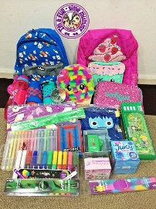
Children should not bring in their own pencil cases – all equipment is provided by school. This includes colouring materials, pens, pencils etc…
Children do not need a school bag. We provide and encourage children to use their reading pack/book bags only as there is limited space in the classrooms and cloakrooms.
Please encourage your child to be independent and prepared to hand in their reading books etc… themselves.
Drop Off and Collection
After School Clubs
It is important that children enter on their own as to ensure the cloakroom environment doesn’t become overwhelming, and to promote their independence. On collection (2:50pm) your child will be allowed to leave once a teacher has seen the collecting adult. Please notify the office in good time if someone else picks up.

There are a variety of after school clubs throughout the year across the school. If these arise for Reception then further information will be sent out in a letter.

- Breakfast Club operates from 8:00 am – 8:50 am each weekday during term time only at a charge of £2.00.
Wrap Around Care / Before and After School Care
- After School Club operates from 2:40/2:50 pm—5:45 pm each weekday during term time only.
The charge for After School Club is as follows:
SESSION 1 - £3.00 (2.40 - 3.15 pm or 3.45 - 4.15 pm for late collection from extra-curricular clubs);
SESSION 2 - £5.50 (2.40 - 5.15 pm);
SESSION 3 - £6.50 (2.40 pm with collection between 5.15 - 5.45 pm).
Health and Safety
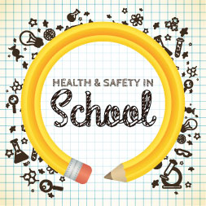
From a health and safety viewpoint it is very important that:
- long hair is tied up. No extreme hairstyles or large bows are permitted.
- your child does not bring in any toys from home
(unless directed by the class teacher);
- the trim trail is not used before and after school;
- smoking or vaping is not permitted on school premises;
- no dogs are permitted on school property
(including carrying the dog);
- you do not park on the school car park, block driveways
of school neighbours or park on the yellow lines.
This ensures the safety of all children.
Reporting Absence / Communication
If your child is going to be absent from school please leave a message on the school answering service on 01706 650280 leaving your child’s name, explain the reason for absence and when you expect your child to return to school.


Ways of communication with parents are via the parentmail app. Please ensure you download the app and set notifications to on. The school newsletter is sent out
every Friday via Parentmail. The newsletter can also be found on the school
website along with any other information you may need.
The school Twitter account is: @stgabscastleton. Please follow us.

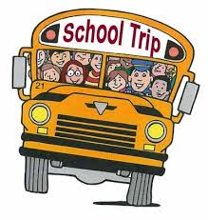
Class teachers also communicate the children’s learning via Seesaw. This is an app you can download to follow your child’s learning. Ask the teacher for a QR code to get started. We want to enhance the children’s learning through school trips and other experiences such as visitors coming into school. Throughout the year your child may be selected to go on a school trip. We ask for a set contribution towards this to enable it to take place as school cannot afford to continually subsidise these opportunities. Therefore, if not enough money is received, we may have to cancel the trips and monies will be lost. Trips will be running when it is safe to do so.
School Trips

Holidays in Term Time
We endeavour to stay open at all times because we want to make every day count. We can authorise absence for some, very rare circumstances but we cannot authorise absences for holidays. If you wish to go on holiday during term time this needs to be put in writing to the Headteacher. It is parents’ duty to have their child attending school and fines may be issued.
Throughout the year children work from the Early Years Curriculum. They are assessed at the end of the year if have achieved the Early Learning Goals in these areas. These are covered in the 7 Areas of Learning
Early Learning Goals

- Communication and Language
- Physical Development
- Personal, Social and Emotional Development
- Literacy
- Mathematics
- Understanding the World
- Expressive Arts & Design

Additional Needs

If you feel your child would benefit from provision over and above their current needs please speak with the class teacher.

The school SENDco is available to answer any questions you may have regarding any additional needs. The school works hard on providing a personalised programme of education and Pupil Passports are devised and reviewed termly with the class teacher, SENDco, parents and children. For more information regarding this, please speak with Mrs Brooks the Deputy Head and SENDco.
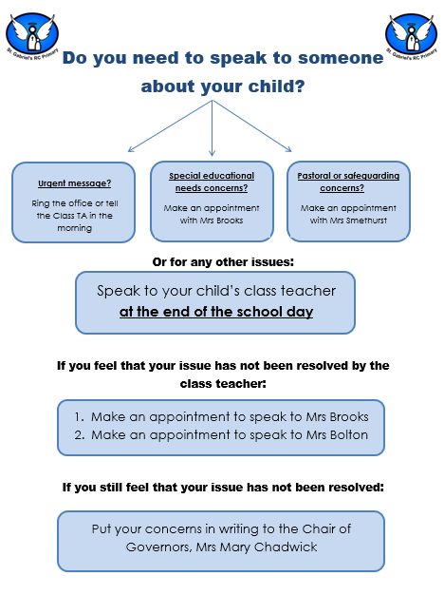
Speaking with Staff

This is a guide of what your child will be learning this year.
EYFS Curriculum


