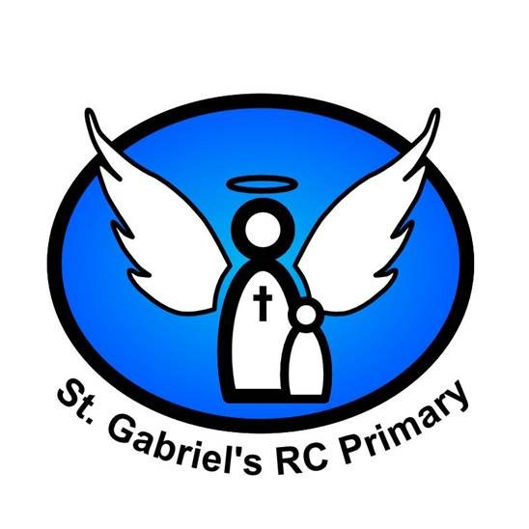
Prayer Handbook

The School Prayer
This is our school
Let Peace dwell here
Let the rooms be full of happiness
Let love abide here
Love of one another, Love of humankind,
Love of life itself and Love of God.
Let us remember that as many hands build a house,
So many hearts make our school.


Reception

Prayer of the Cross
From my head to my heart,
From my shoulder to my shoulder,
I love you God my Father.
Jesus, friend of little children,
Be a friend to me.

The Sign of the Cross
In the name of the Father
and of the Son
and of the Holy Spirit. Amen.
The sign of the cross is both an action and a statement of faith.
A physical reminder of our redemption in the cross and an expression of faith in the Trinity.

School Prayer
This is our school
Let Peace dwell here
Let the rooms be full of happiness
Let love abide here
Love of one another, Love of humankind,
Love of life itself and Love of God.
Let us remember that as many hands build a house,
So many hearts make our school.

Year 1

The Lord’s Prayer
Our Father who art in heaven,
hallowed be thy name.
Thy kingdom come.
Thy will be done on earth,
as it is in heaven.
Give us this day our daily bread,
and forgive us our trespasses,
as we forgive those who trespass against us,
and lead us not into temptation,
but deliver us from evil.
The Lord’s Prayer ‘is truly the summary of the whole of the Gospel’. (CCC 2761.)

The Hail Mary
Hail, Mary, full of grace,
the Lord is with thee.
Blessed art thou among women
and blessed is the fruit of thy womb, Jesus.
Holy Mary, Mother of God,
pray for us sinners,
now and at the hour of our death.
Amen.
The first part of the Hail Mary is biblical, drawn from Gabriel’s greeting to Mary at the
Annunciation and Elizabeth’s greeting at the Visitation. The second part of the prayer has its origins in 15th-century Italy.
KS1 Morning Prayer
Oh my God, you love me
You’re with me night and day
I want to love you always,
In all I do and say
I’ll try to please you Father,
Bless me through the day,
Amen

KS1 Grace Before Meals
Bless us, oh Lord, as we sit together,
Bless the food we eat today,
Bless the hands that made the food,
Bless us, oh Lord, Amen.

Grace After Meals
Thank you God for the food we have eaten,
Thank you God for all our friends,
Thank you God for everything,
Thank you God,
Amen.

Evening Prayer
God our Father, I come to say
Thank you for your love today,
Thank you for my family
And all the friends you give to me
Guide me in the dark of night
And in the morning, send your light,
Amen

Year 2

Glory be to the Father
Glory be to the Father
and to the Son
and to the Holy Spirit,
as it was in the beginning
is now, and ever shall be
world without end. Amen.
The doxology is a short expression of praise of the Trinity dating back to the early Church.
It is used extensively in the Liturgy of the Hours and in devotions such as the Rosary.

Angel of God
Angel of God,
my guardian dear,
to whom God’s love commits me here,
ever this day be at my side,
to light and guard, to rule and guide.
Amen.
The prayer is based on one by Reginald of Canterbury in the early 12th century.

Year 3

The Apostles’ Creed
I believe in God,
the Father almighty
Creator of heaven and earth,
and in Jesus Christ, his only Son, our Lord,
At the words that follow, up to and including the Virgin Mary, all bow.
who was conceived by the Holy Spirit,
born of the Virgin Mary,
suffered under Pontius Pilate,
was crucified, died and was buried;
he descended into hell;
on the third day he rose again from the dead;
he ascended into heaven,
and is seated at the right hand of God the Father almighty;
from there he will come to judge the living and the dead.
I believe in the Holy Spirit,
the holy catholic Church,
the communion of saints,
the forgiveness of sins,
the resurrection of the body,
and life everlasting. Amen.
Based on baptismal documents of the 8th century
but related to texts of an earlier origin.

Act of Contrition
O my God,
because you are so good,
I am very sorry that I have sinned against you,
and by the help of your grace
I will try not sin again.
One of the forms of the Penitent’s Prayer of Sorrow found in the Rite of Penance.
KS2 Morning Offering
O Jesus,
through the most pure heart of Mary,
I offer to you all my prayers,
Works, sufferings and joys of this day,
for all the intentions of your divine heart. Amen

KS2 Grace Before Meals
Bless us, O Lord, and these thy gifts
which we are about to receive from thy bounty.
Through Christ our Lord.
Amen.

Year 4

Come, Holy Spirit
V. Come, Holy Spirit, fill the hearts of your faithful.
R. And kindle in them the fire of your love.
V. Send forth your Spirit and they shall be created.
R. And you will renew the face of the earth.
Let us pray
O God, who by the light of the Holy Spirit,
did instruct the hearts of your faithful,
grant that by that same Holy Spirit,
we may be truly wise, and ever rejoice in your consolation,
Through Christ our Lord.
Amen.
This prayer is a compilation of a number of liturgical texts drawn from the
Mass and Office of Pentecost and the Votive Mass of the Holy Spirit.

Prayer of St Richard of Chichester
Thanks be to you, my Lord Jesus Christ,
for all the benefits which you have given me,
for all the pains and insults which you have borne for me.
O most merciful Redeemer, friend and brother,
may I know you more clearly,
love you more dearly,
and follow you more nearly,
day by day.
Amen.

Eternal Rest
Eternal rest grant unto them, O Lord,
and let perpetual light shine upon them.
May they rest in peace. Amen.
Based on the Entrance Antiphon of the Mass for the Dead.

Year 5

The Rosary
For each mystery or decade, one Our Father, ten Hail Marys and the Glory be is recited.

The Joyful Mysteries
(Recited Monday and Saturday)
The Annunciation (Luke 1:26–38)
The Visitation (Luke 1:39–45)
The Nativity (Luke 2:1–7)
The Presentation in the Temple (Luke 2:22–35)
The Finding in the Temple (Luke 2:41–52)

The Mysteries of Light
(Recited Thursday)
The Baptism of Jesus (Matthew 3:13–17)
The Wedding Feast of Cana (John 2:1–12)
The Proclamation of the Kingdom, with the call to Conversion (Mark 1:14–15; 2:3–12)
The Transfiguration (Luke 9:28–36)
The Institution of the Eucharist (Matthew 26:26–29)

The Sorrowful Mysteries
(Recited Tuesday and Friday)
The Agony in the Garden (Mark 14:32–42)
The Scourging at the Pillar (Matthew 27:15–26)
The Crowning with Thorns (Matthew 27:27–31)
The Carrying of the Cross (John 19:15–17; Luke 23:27–32)
The Crucifixion (Luke 23:33–38, 44–46)

The Glorious Mysteries
(Recited Wednesday and Sunday)
The Resurrection (Matthew 28:1–8)
The Ascension (Acts 1:6–11)
The Descent of the Holy Spirit (Acts 2:1–12)
The Assumption (1 Thessalonians 4:13–19)
The Coronation of Mary Queen of Heaven and Earth (Revelation 12:1; 14:1–5; Isaiah 6:1–3)

Prayer concluding the Rosary
[Hail, Holy Queen, etc. as above]
V. Pray for us, O holy Mother of God.
R. That we may be made worthy of the promises of Christ.
Let us pray.
O God, whose only-begotten Son,
by his life, death and resurrection,
has purchased for us the rewards of eternal life,
grant, we beseech thee,
that meditating on these mysteries
of the most holy Rosary of the Blessed Virgin Mary,
we may imitate what they contain
and obtain what they promise,
through the same Christ our Lord. Amen.

The Magnificat
My soul proclaims the greatness of the Lord,
and my spirit rejoices in God my Saviour,
for he has looked upon his handmaid in her lowliness;
for behold, from this day forward,
all generations will call me blessed.
For the Almighty has done great things for me,
and holy is his name.
His mercy is from age to age
for those who fear him.
He has made known the strength of his arm,
and has scattered the proud in their conceit of heart.
He has cast down the mighty from their thrones
and has exalted those who are lowly.
He has filled the hungry with good things,
and has sent the rich away empty.
He has helped his servant Israel,
mindful of his mercy,
even as he promised to our fathers,
to Abraham and his descendants for ever.
Glory be to the Father and to the Son
and to the Holy Spirit,
as it was in the beginning, is now,
and ever shall be, world without end.
Amen.
Year 6

Act of Faith
My God, I believe in you
and all that your Church teaches,
because you have said it,
and your word is true.

Act of Hope
My God, I hope in you,
for grace and for glory,
because of your promises,
your mercy and your power.

Act of Love
My God, because you are so good,
I love you with all my heart,
and for your sake,
I love your neighbour as myself.

