 |  |  | Autumn 1 | Autumn 2 | Spring 1 | Spring 2 | Summer 1 | Summer 2
Religion |  |  | Come and see  Domestic Church – Family – ourselves  Baptism/ confirmation – life choices | Come and see  Baptism/ confirmation – life choices  Advent/ Christmas – Loving – hope | Come and see  Local church – community – mission  Eucharist – Relating – Memorial Sacrifice | Come and see  Eucharist – Relating – Memorial Sacrifice  Lent/Easter – Giving – Sacrifice | Come and see  Pentecost – Serving – Transformation | Come and see  Reconciliation – inter-relating - Freedom and responsibility
Caritas In Action |  |  | 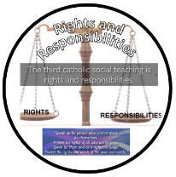 |  | 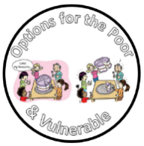  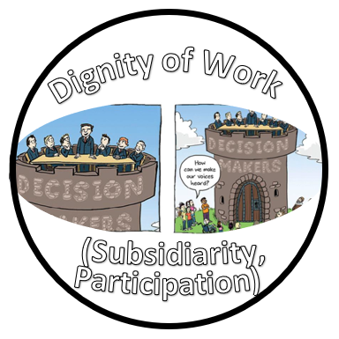 | 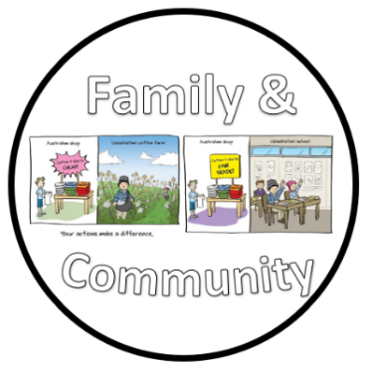  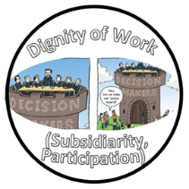 | 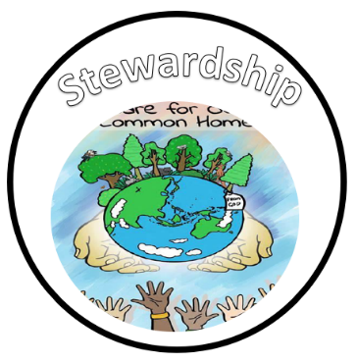  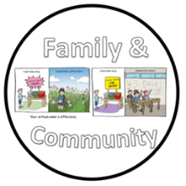 | 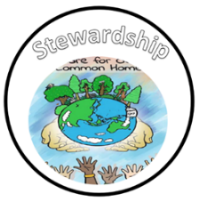
World Faiths |  |  | Hinduism |  | Islam |  | Judaism
Careers |  |  | Relating to people whose identities and backgrounds are different to their own.  Comparing religious beliefs and practices in RE |  | Being able to design a scheme for classifying a set of jobs  Exploring the connection between uniforms and status –link to role of people in the church and the role of the Bishops etc.  Making a step-by-step plan to enable them to achieve something they would like to be able to do – charities work, Mission RE  Earth and Space – famous people who have made steps in space.  Exploring what they and others can do to prevent people having to do harmful work – link to RSE and Blurred Lines (County Lines workshops) |  | Recognising that people seek different rewards when considering paid work that they’d like to do – History link – what jobs did people do during WW2?  Exploring jobs and ways of  working that help to protect the  environment  Being aware that people’s work needs change during their lives – Windrush link – link to sacrifices big question.
Shared Reading / Phonics |  |  | Leo and the Gorgon’s curse – Joe Todd Stanton | Percy Jackson and the lightening thief – Rick Riordan | Bron – The adventures of an Anglo Saxon  Beowolf | Wonder – RJ Palacio | Goodnight Mister Tom | Goodnight Mister Tom  Non-fiction texts WW2
English Genre Coverage |  |  | Text: Greek Gods and Heroes – 40 inspiring icons  Genre: Narrative  Purpose: To entertain | Text: Percy Jackson and the lightening thief  Genre: Letter writing (formal)  Purpose: To persuade  Genre: Dialogue  Purpose: To entertain | Text: Freedom from Bron – N.S Blackman  The Anglo Saxon Boy– Tony Bradman  Genre: Instructions – How to raid a farm  Purpose: To inform  Genre: Informal letter/diary entry  Purpose: To inform  Genre: Poetry  Purpose: To Entertain – Based around chapter 16 - Kennings | Wonder – R.J Palacio  Genre: Narrative – dialogue focus  Purpose: To entertain  Genre: Newspaper article  Purpose: To inform  Genre :Letter writing  Purpose: Persuasive | The autobiography of a bear named Otto  Genre: Character description  Purpose: To entertain  Genre: Letter  Purpose: To inform – Evacuee in History lesson  Genre: Setting description  Purpose: To entertain | Goodnight Mister Tom  Genre: Instructions  Purpose: To inform  Genre: Non chronological report  Purpose: Inform
Text, Word, Sentence Structure and Punctuation  (see writing overview for more details) |  |  | - Recapping and embedding previous year groups objectives  - Sentence structure  - Expanded noun phrases  - Use of ?!.  - Co-ordinating conjunctions  - Subordinating conjunctions  - Fronted adverbials | - Persuasive language  - Informal language  - Devices to build cohesion within a paragraph  - Linking ideas across paragraphs using adverbials of time  - Indicating degrees of possibility using adverbs or modal verbs | - Verb prefixes  - Indicating degrees of possibility using adverbs or modal verbs  - Inverted commas  - Dialogue  - Brackets, dashes or commas to indicate parenthesis | - Relative pronouns and clauses.  - Dialogue  - Brackets, dashes or commas to indicate parenthesis | - Formal and informal language  - Descriptive language  - Converting nouns or adjectives into verbs using suffixes  - ~ Use of commas to clarify meaning or avoid ambiguity. | - Modal verbs  - Relative clauses  - ~ Use of commas to clarify meaning or avoid ambiguity.
Maths  (White Rose outline) |  |  | Place value  Addition and subtraction  Multiplication and division A | Multiplication and division A  Fractions A | Multiplication and division B  Fraction B  Decimals and Percentages | Fraction B  Decimals and Percentages  Perimeter and Area  Statistics | Shape  Position and direction  Decimals | Number - Negative numbers  Converting units  Measurement - volume
Science |  |  | Forces | Materials and their properties | Earth and Space | Living things and their habitats | Animals, including humans | Health, fitness, diet and exercise
History |  |  | Ancient Greece | Ancient Greece | Anglo Saxons |  | World War 2 | World War 2
Geography |  |  | Ancient Greece |  |  | North America |  | World War 2
Art |  |  | I need space (drawing) |  |  | Portraits (painting and mixed media) | Interactive installation (sculpture and 3D)
Design and Technology |  |  |  | Pop up books | Doodlers (electrical systems) |  | Textiles-Stuffing a toy | What could be healthier?
Computing |  |  | Quizzing | Databases  Game Generator | Spreadsheets | Coding | Word Processing | Concept Maps
PE |  |  | Invasion games  Gymnastics | Dance  Athletics | Invasion games  Gymnastics/dance | Invasion games  Athletics | Striking and fielding  Net/wall games | Striking and fielding  Net/wall games
Music |  |  | Composition Notation (Theme: Ancient Egypt) | Blues | South and West Africa | Composition to Represent the Festival of Colour (Theme: Holi Festival) | Musical Traditions | Popular Music:  1) 90s RnB, Say My Name, Destiny’s Child  2) Art Pop, Running up that Hill, Kate Bush
Foreign Language |  |  | Saying more about ourselves  School subjects and opinions | In the city  Buying a present | Going to the market | Clothes and fashion shows | Planets  Travellers ID | seaside
PSHE |  |  | Health and Wellbeing and Relationships are covered by the Ten:Ten ‘Life to the Full’ scheme of work.  Living in the Wider World is covered through:  Shared Responsibilities – Caritas in Action (Stewardship and Rights & Responsibilities), school rules and Eco Schools. Needs of caterpillars / butterflies.  Media Literacy and Digital Resilience – E-Awareness lessons and E-safety week.  Economic Wellbeing: Aspirations, Work and Career – Career day assemblies / guest speakers from the community and from charities / Celebration Assemblies.
RSE |  |  | Calming the Storm  Gifts and Talents  Girls’ Bodies Boys’  Bodies Spots and Sleep  Menstruation  Hope beyond Death |  | Body Image  Peculiar feelings  Emotional changes  PANTS lesson  Friendships |  | God is Calling You  Enterprise/Aspirations Activities  Under Pressure
British Values and Diversity |  |  |  | Democracy – Ancient Greek rulers | The rule of law – compare modern day and Anglo Saxon crime and punishment |  | Tolerance and respect – Holocaust | Tolerance and respect – Windrush  Individual liberty – wind rush
Eco Schools |  |  | Energy – renewable and non-renewable | Litter and waste |  |  | Recycling | Healthy Living  Global Citizenship
Curriculum in Action  Immersive experiences |  |  | Touchstones – Ancient Greek Loan Box  Macmillan Coffee morning  ST Gabriel’s Day  National Poetry Day  TTRS Launch day | Ancient Greek theme day – dress up  Christmas bedtime stories  UK Parliament week  RockKidz  Remembrance service  Carols around the tree  Christmas jumper day  Anti- bullying week  Pantomime visit  Nativity  Anti-bullying Week | Recycling workshop  Storytelling week  Children’s mental health week  E safety day  Art and D and T gallery  An artist visit | World Book Day / World Book Week  Science week  St Gabriel’s got Talent  Stations of the cross  Autism acceptance week  Neurodiversity Week | May procession  St Gabriel’s Got Talent  Fieldwork week  Rochdale Music Festival  Sports Day | Tatton Park – WW2 trip/Stockport Air Raid Shelters  Health and nutrition week  Gabrielbury
Oracy | Physical |  |  | For body language to become increasingly natural. |  |  | To project their voice to a large audience.
Oracy | Linguistic |  | To use an increasingly sophisticated range of sentence stems with accuracy.  To select specific vocabulary appropriate to the topic at hand.
Oracy | Cognitive |  |  |  | To identify when a discussion is going  off topic and to be able to bring it  back on track. | To be able to draw upon knowledge of the world to support their own point of view and explore different perspectives.
Oracy | Social and Emotional |  | Listening actively for extended periods of time. | To speak with flair and passion.

