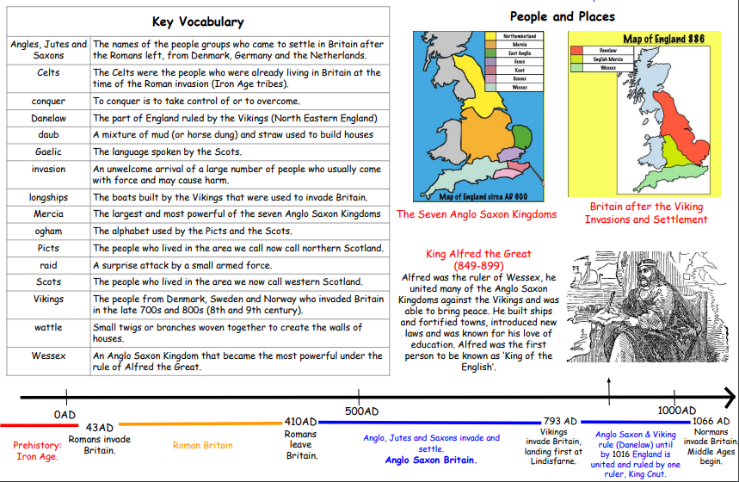
Our Topic is: Anglo Saxons

